# **Build-process and development-process(package.json file)**

Copy the scripts and dependencies into your current project **package.json** file

Remember that .json files do not allow comments, so remember not to paste those

Our basic command promt tasks that will both compile-sass and run live-server in parallel during development, as well as our four-in-one tasks that will actually compile, concat, prefix and compress our project, making it ready for deployment, in a single **build:css** runable task.

Copy paste the “scripts” from here when setting up a web-dev environment as well as for enabling deployment on your current project.

{

  "name": "natours",

  "version": "1.0.0",

  "description": "Landing page for natours",

  "main": "index.js",

//Copy all the scripts for running the process in your current project

  "scripts": {

    "watch:sass": "node-sass sass/main.scss css/style.css -w",

    "devserver": "live-server",

    "start": "npm-run-all --parallel devserver watch:sass ",

    "compile:sass": "node-sass sass/main.scss css/style.comp.css",

    "concat:css": "concat -o css/style.concat.css css/icon-font.css css/style.comp.css",

    "prefix:css": "postcss --use autoprefixer -b 'last 10 versions' css/style.concat.css -o css/style.prefix.css",

    "compress:css": "node-sass css/style.prefix.css css/style.css --output-style compressed",

    "build:css": "npm-run-all compile:sass concat:css prefix:css compress:css"

  },

  "author": "Adam",

  "license": "ISC",

//Copy all of the dev-dependencies (installed packages so the process tasks work)

  "devDependencies": {

    "autoprefixer": "^10.2.1",

    "concat": "^1.0.3",

    "node-sass": "^5.0.0",

    "npm-run-all": "^4.1.5",

    "postcss": "^8.2.4",

    "postcss-cli": "^8.3.1"

  },

  "dependencies": {

    "install": "^0.13.0",

    "live-server": "^1.2.1"

  }

}

# **GRID USING FLOAT**

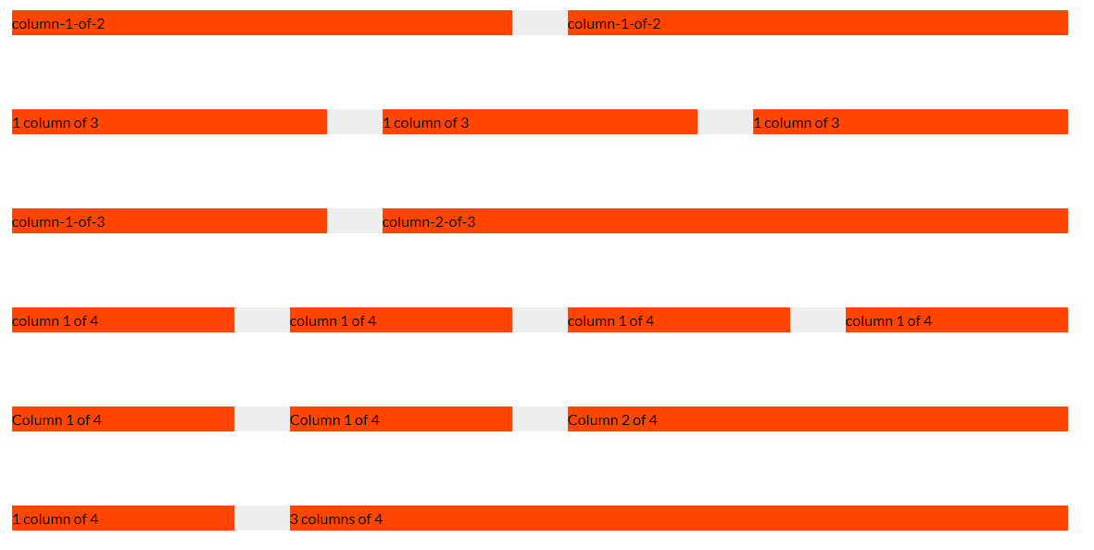

**_grid.scss**

.row {

  max-width: $grid-width; /*1140px*/

  background-color: #eee;

  margin: 0 auto

  //Setting up the gutter between the rows

  &:not(:last-child) {

    margin-bottom: $gutter-horizontal;

  }

  //Insert clearfix before our columns

  @include clearfix; //.row::after{clearfix-content}

//Style all our columns

  [class^="column-"] {

    background-color: orangered;

    float: left;

    //Setting up the gutter between the columns

    //gives a margin-right to all columns except the last(child)one

    &:not(:last-child) {

      margin-right: $gutter-vertical;

    }

  }

  //Setting up the columns with the following algorithm

  // (100%rowWidth -(numberOfGutters*gutterWidth))/NumberOfColumns;

  //Note that {numberOfGutters = NumberOfColumns-1;}

  //#####FOR ALL COLUMNS THAT ARE A HALF 1/2

  .column-1-of-2 {

    width: calc((100% - #{$gutter-vertical}) / 2);

  }

 //#####FOR ALL COLUMNS THAT ARE A THRID 1/3 lenght

  .column-1-of-3 {

    width: calc((100% - 2 * #{$gutter-vertical}) / 3);

  }

  //###FOR ALL COLUMNS THAT ARE 2/3 TWO THIRDs lenght

  .column-2-of-3 {

    width: calc(

      2 * ((100% - 2 * #{$gutter-vertical}) / 3) + #{$gutter-vertical}

    ); //1third times two

  }

  //###FOR ALL COLUMNS THAT ARE 1/4 quarters length

  .column-1-of-4 {

    width: calc((100% - 3 *#{$gutter-vertical}) / 4);

  }

  //###FOR ALL COLUMNS THAT ARE TWO QUARTERS LENGTH 2/4

  .column-2-of-4 {

    width: calc(

      2 * ((100% - 3 * #{$gutter-vertical}) / 4) + #{$gutter-vertical}

    ); //1third times two

  }

  //###FOR ALL COLUMNS THAT ARE Three quarters length 3/4

  .column-3-of-4 {

    width: calc(

      3 * ((100% - 3 * #{$gutter-vertical}) / 4) + 2 *#{$gutter-vertical}

    ); //1third times two

  }

}

**_mixins.scss**

@mixin clearfix {

  &::after {

    content: ""; //empty so we don't see the element

    display: table;

    clear: both; //clears both float left and right

  }}

**_variables.scss**

$grid-width: 114rem;

$gutter-horizontal: 8rem; //80px (gutter between rows)

$gutter-vertical: 6rem; //60px (gutter between columns)

**Html**

    <!--#####TEMPLATE GRID LAYOUT -->

    <section class="grid-test">

      <div class="row">

        <div class="column-1-of-2">column-1-of-2</div>

        <div class="column-1-of-2">column-1-of-2</div>

      </div>

      <div class="row">

        <div class="column-1-of-3">1 column of 3</div>

        <div class="column-1-of-3">1 column of 3</div>

        <div class="column-1-of-3">1 column of 3</div>

      </div>

      <div class="row">

        <div class="column-1-of-3">column-1-of-3</div>

        <div class="column-2-of-3">column-2-of-3</div>

      </div>

      <div class="row">

        <div class="column-1-of-4">column 1 of 4</div>

        <div class="column-1-of-4">column 1 of 4</div>

        <div class="column-1-of-4">column 1 of 4</div>

        <div class="column-1-of-4">column 1 of 4</div>

      </div>

      <div class="row">

        <div class="column-1-of-4">Column 1 of 4</div>

        <div class="column-1-of-4">Column 1 of 4</div>

        <div class="column-2-of-4">Column 2 of 4</div>

      </div>

      <div class="row">

        <div class="column-1-of-4">1 column of 4</div>

        <div class="column-3-of-4">3 columns of 4</div>

      </div>

    </section>

# **<a> anchor-button with a press animation**

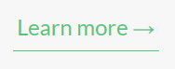

Figure LINK STATE

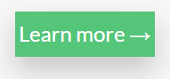

Hover state (rises slightly)

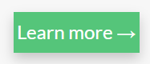

Lowers to original link-state position(lessshadow

.btn-pressable {

  &:link,

  &:visited {

    font-size: $default-font-size;//Use your own variable values

    color: $color-primary;

    display: inline-block; /*to be able to use margin/padding*/

    text-decoration: none;

    border-bottom: 1px solid $color-primary;

    padding: 3px; //It is okay for really small units to stay unresponsive(px)

    transition: all 0.2s;

  }

  &:hover {

    background-color: $color-primary;

    color: white;

    box-shadow: 0 1rem 2rem rgba($color-black, 0.2);

    transform: translateY(-2px);

  }

  &:active {

    transform: translateY(0); //Relative to the link state, not hover state

    box-shadow: 0 0.5rem 1rem rgba($color-black, 0.2);

  }

}

### **Creating an image composition**

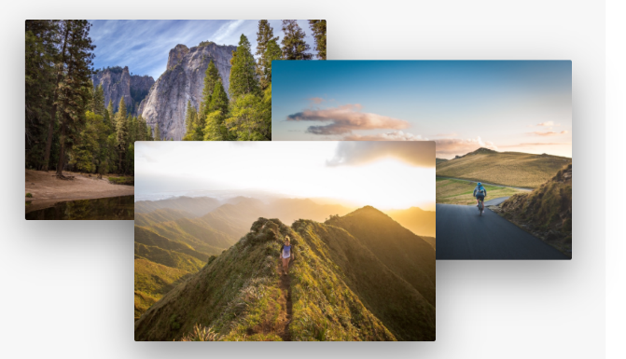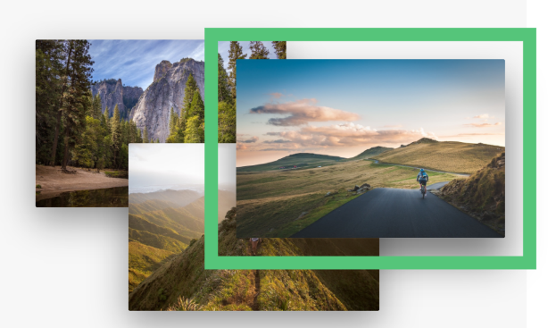

**Normal layout On hover one image gets bigger**

**While all others get smaller**

.composition {

  position: relative;

  transition: all 0.3s;

  &:hover &__photo:not(:hover) {

    transform: scale(0.98);

  }

  //&__photo == .composition__photo

  &__photo {

    width: 55%;

    box-shadow: 0 1.5rem 4rem rgba($color-black, 0.4);

    border-radius: 2px;

    position: absolute;

    z-index: 10;

    transition: all 0.3s;

    outline-offset: 2rem; /*20px*/

    &--p1 {

      left: 0;

      top: -2rem;

    }

    &--p2 {

      right: 0;

      top: 2rem;

    }

    &--p3 {

      left: 20%;

      top: 10rem;

    }

    // .composition__photo:hover

    &:hover {

      outline: 1.5rem solid $color-primary;

      transform: scale(1.05) translateY(1rem);

      //The element is now closer to the user

      //so it should have a larger, less bright shadow

      box-shadow: 0 2.5rem 4rem rgba($color-black, 0.5);

      z-index: 20; //making sure our element always displays on top

    }

  }

}

  <!--Second column element-->

          <div class="column-1-of-2">

            <div class="composition">

              <img

                src="images/nat-1-large.jpg"

                alt="Image 1"

                class="composition__photo composition__photo--p1"

              />

              <img

                src="images/nat-2-large.jpg "

                alt="Image 2"

                class="composition__photo composition__photo--p2"

              />

              <img

                src="images/nat-3-large.jpg "

                alt="Image 3"

                class="composition__photo composition__photo--p3"

              />

            </div>

          </div>

## **Rotating-Card component**

### (As complex as it is awesome!)

A very complex component in web-design

A card that rotates Is in fact created by two cards, that are positioned absolutely and aligned at the top: 0, left:0; position relative to their shared parent element  
This means that they overlap each other.

Something that is utiilized to make each other selectively visible one after the other, on rotation, is the backface-visibility property.

If the **backface-visibility** is set to **hidden** for both elements, that means that only the element that is currently facing us with its normal layout (front side) is going to be visible.

Or to summarize the principle in an even more simple manner

When an element has **backface-visibility: hidden;** it becomes transparent (invisible) so the element behind it becomes visible.

If we were to have two elements with **backface-visibility: hiddent**; one on top of the other,

If the one on top is turned 180degrees (flipped) the one behind it will become transparent. Now there is the aspect of animating them both, so in that sense( they both have to turn) and it makes sense that when the front image turnes 180degrees, the back of the image turns 180degrees as well, so that we have an animation of both images turning (and not the front rotating to unveal a static image behind it.

### **Setting up the card**

1.Have both image-cards on top of each other, positioned absolute in a position:relative 🡪 parent.

2.Have both front and back images apply the property value of **backface-visibility:hidden**

3.The front image will rotate around the Yaxis 180degrees, which means that the starting position of the front image is **transform:rotateY(0);** While the starting position of the backfaceImage is **transform:rotateY(180deg)** its backface is already showing so it is invisible. In other words,

Front image starts at 0degrees rotation (stays unchanged)

The back-image at the start is rotated (180deg) its backface showing so it is transparent.

### **Rotating the card**

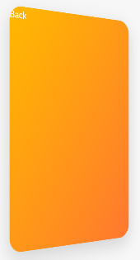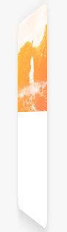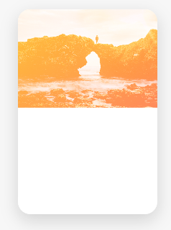

On hover we want the following:

**- back image to become visible(no longer transparent)** (that meanst that it should rotate so its backface is turned to the back, and the front-face turned to the user)

**-front image to become invisible(transparent)**(meaning that it should rotate so it’s invisible(transparent)backface is turned to the front, so that now the user can see throught the transparent backface of the front image, the rotating and visible part of the back imageas it too becomes visible (as it turns from its own backface to frontface)

.card {

  //Functionality

  perspective: 150rem;//perspective has to be set on the parent of the rotating child

  -moz-perspective: 150rem;

  position: relative;

  height: 50rem;

//gives the parent a height after its absolute children move out of the parent layout

  &__side {

    color: #fff;

    font-size: 2rem;

    height: 50rem;

    width: 100%;

    transition: all 0.8s ease;

    position: absolute;

    top: 0;

    left: 0;

   backface-visibility: hidden;

    border-radius: 30px;

    overflow: hidden;//hides the background image sticking over border radius

    box-shadow: 0 1.5rem 4rem rgba($color-black, 0.15);

    &--front {

      background-color: $color-white;

    }

    &--back {

      transform: rotateY(180deg);

  //.card:hover .card__side

  &:hover &__side--front { //when the parent is hovered rotate the child element

    //shows the backside

    transform: rotateY(-180deg);

  }

  &:hover &__side--back { //when the parent is hovered rotate the child element

    //shows the front siden

    transform: rotateY(0);

  }

 <div class="column-1-of-3"> <!—A container for the card (defines its dimention)🡪

            <!--Card1-->

            <div class="card">

              <!--Front of the card-->

              <div class="card__side card__side--front card__side--front-1">

                <div class="card__picture card__picture--1">

                  &nbsp;<!--Empty space html symbol-->

                </div>

                <div class="card__heading">Heading</div>

                <div class="card__details">Details</div>

              </div>

              <!--Back of the card-->

              <div class="card__side card__side--back card__side--back-1">

                Back

              </div>

            </div>

          </div>

Note that the two images mentioned above are in fact two <div> elements with a background-image property.They are both inside the <div class="card"> parent element, which has position relative, while the children “card__side—front” and “card__side—back” have the position:absolute; top:0; left:0 🡪 referencing the top left position of their parent “card” div element.

Note that their specific styles are defined in the modifier &--front and &--back classes, while their position (as they are both one side of the card) is defined in their more general shared class “card__side” referenced nested inside the parent “card” element as &__side{position:absolute;…} It is something to note.

To reiterate &--front and &--back are two divs that are normally stacked on top of each other(being block level elements) taking the whole horizontal space of a parent column-layout component, that divides a row into thirds.

Being block level elements, the only way to make them stack on top of each other is to absolutely position them, relative to their parent “card” element, that is currently constrained inside the the space within the “column-1-of-3

So the block elements stack one over the other, all the while remaning inside the inherited space of the parent . <div class="card">’s parent 🡪 <div class="column-1-of-3">

The size of the card later defined by styling the <div class="card"> element and its children (as we should never style the layout element-components that we use for aligning our elements on the webpage, which are in this case the components used to create a grid using floats by floating column divs inside row divs, whereby we’ve here borrowed a row and a floated column: <div class="column-1-of-3"> (always create additional divs for the elements you insert into the layout components, and style those instead!!!)

## **Center align absolutely positioned elements(revisited)**

  &__callToAction {

    //Aligning an absolutely positioned

    position: absolute;

    top: 50%;

    left: 50%;

    transform: translate(-50%, -50%);

  }

What we are doing basically is:

1.first centering the child elements top left corner on the center of the parent element: top: 50%; left: 50%;

2.Then moving the center of the child element itself to the position where currently its top left corner resides.

So we translate it by half of its own width to the left on the X axis so that now the center of the element is directly lying on the y axis of the parent element

3.Then we proceed by moving the element up by half of its own height on the Y axis, therefore placing the exact center (50% threshold) of the element’s height on the parent X axis

transform: translate(-50%, -50%);

## Skewing an entire section

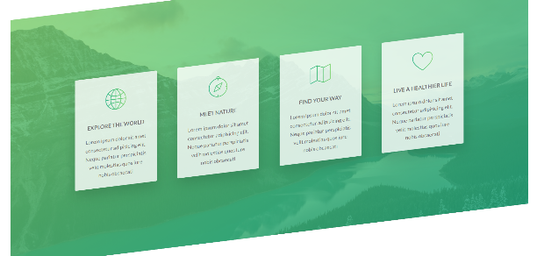

The section is called the **.section-features.**

We can see that after skewing the section and all of its child elements get skewed together… Har, har… -_-

To get the child elements to return to their original position, we simply have to skew all of the .section-features’s child elements in the opposite direction that the section itself skews in

.section-features{

ransform: skewY(-7deg);

  //Below is a Direct child selector

  //.section-features>*

  & > * {

    //skewing the child elements in the opposite direction

    // skew 7deg + skew -7deg = skew 0deg

    transform: skewY(7deg);}

  }

}

Now the section is skewed while the child elements are not

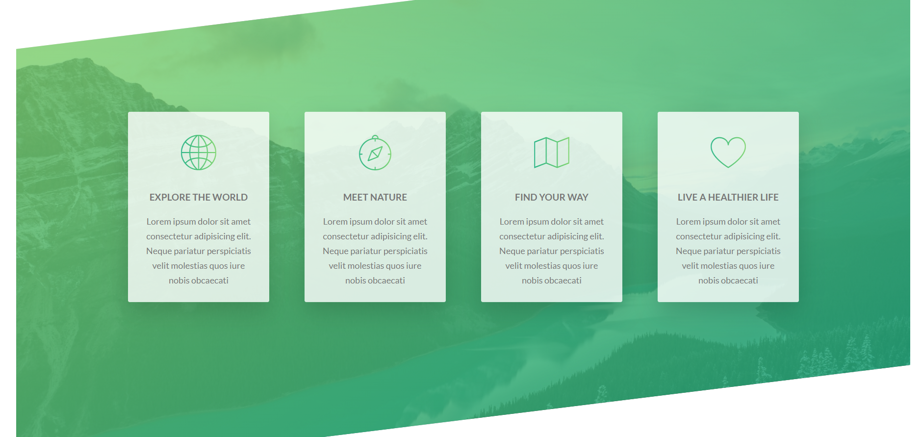

**Using negative top/bottom-margins to**

## **Adding a video background to a section (html5 video element)**

Get some free background videos from **COVERR.co**

**(**[Free Stock Footage | Royalty Free Videos for Download | Coverr](https://coverr.co/))

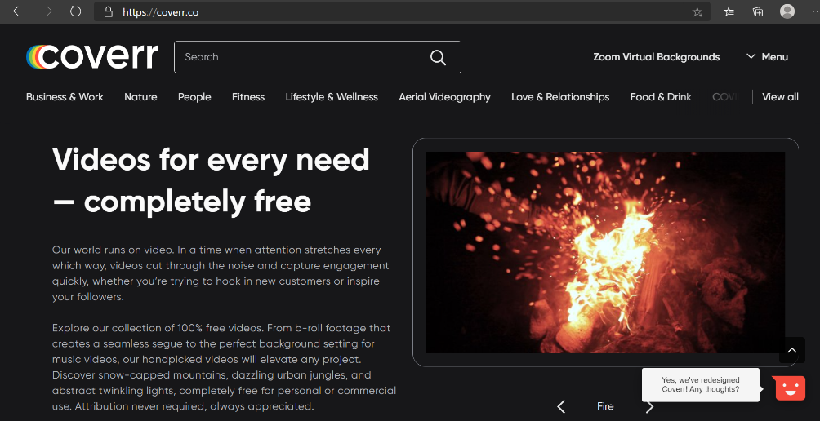When you download from this site, you will get both video formats used in the <video> <source> tags. Web, **video/mp4 and video/webm**

The tags that you’ll be using to embed videos

<section class="section-stories">

        <div class="background-video">

          <video class="background-video__content">

            <source src="images/video.mp4" type="video/mp4" />

            <source src="images/video.webm" type="video/webm" />

          </video>

        </div>

<section/>

### **Positioning and sizing the background overlay(div)**

You want to have an absolutely positioned div positioned over the section element that you are creating a background image for. Make the background-video div the same height and width as the section you want it to cover. Give it a z-index so that it is placed behind the section, then give the section a transparent background, e voila, you got a working background video.

### **Getting the video source using the <source> html5 tag**

Videos are not sourced like images, using the src attributes inside the video tag (even though they come equiped with one), instead, for sourcing videos we will be using a separate **source** tag.

In the source-tag, we’d pass a directory path to **its** src attribute (so not the video tag’s src, but the source’s src) as well as the video type, in the **type** attribute, so that the browser knows how to render the video. **Mp4 and webm.** Having one video in each format makes sure it runs in all browsers!

## **Assigning commands to the video tag**

In order to control the way our video behaves, we have various html commands supported for our use.

Generally for background videos we’d be inserting the following commands:

* **Autoplay**(makes the video play automatically/usually bad practice if it is not a background vid
* **Muted**(Users should always be given the option to chose sound, also, background vids generaly don’t need to have a sound)
* **Loop** (if loop command is ommited, the video will play once per parge reload, by default)

 <!--Background video overlay-->

        <div class="background-video">

          <video class="background-video__content" autoplay muted loop>

            <source src="images/video.mp4" type="video/mp4" />

            <source src="images/video.webm" type="video/webm" />

            Your browser is not supported to display the video!

          </video>

        </div>

The comments placed inside the video tag (the text inside) is set to appear in those cases that the browser does not support the sourced video’s. (Old internet explorer versions, what else? :P

#### **Note on changing background opacity**

Never use the **opacity** property if you want to make a background of a section transparent, as a lower opacity set on a parent element is inheritable. This means that all the text, images, and other stuff of the child elements will also be as transparent as the parent(unless a conflicting opacity property is set for them specifically as well)

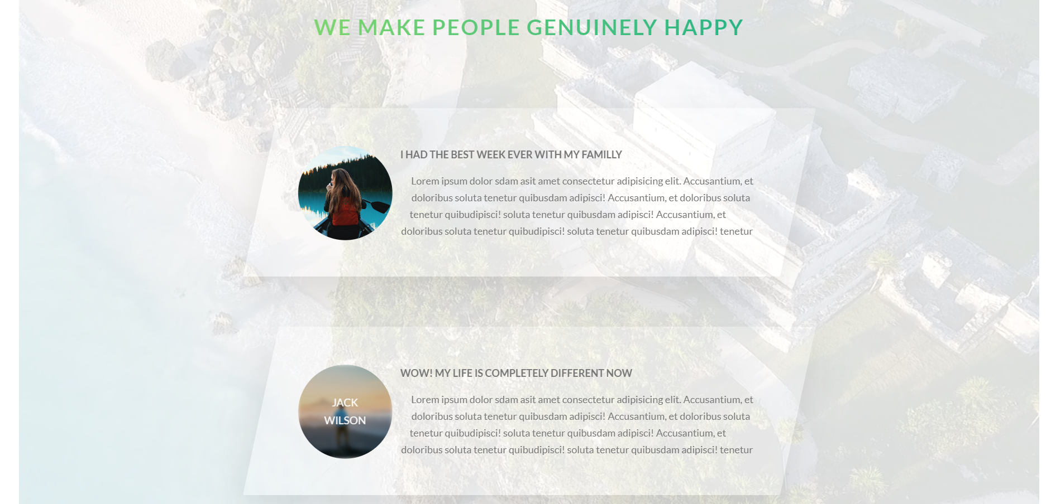

### **Object-fit property**

.parentContainer{

height:90rem;

width:120rem;

&__video {

    height: 100%;//90rem

    width: 100%;//120rem

    object-fit: cover; //similar to background-size:cover;

    //It makes the element fill its entire parent while still maintaining its aspect ratio

   }

}

Just like **background-size: cover;** is used to make a background-image, stretch over to fill an entire parent element(without losing its original aspect ratio) **object-fit** property does the same for other html elements, that are not background-image/types, like <videos>, and actually <img> tags too!

How it works is, whenever we have an <img> or <video> inside a parent container element, we can make those img/video elements cover the entirety of the parent element without losing their aspect ratio, by giving the video/img selectors the property of **object-fit:cover;**

**Object-fit: cover; 🡪** Maintains aspect ratio (covers the entirety of the parent, clips what can’t fit)

**Object-fit:fill; 🡪** Does not maintain aspect-ratio but makes the object fit the parent (stretches or shrinks in the x or y axis)

**Object-fit:contain; 🡪** Stretches or shrinks the video/image, making sure not to crop anything from the video or image (re-adjusts the size in order to make everything fit without cropping)

## **Shaping** **content** **around** **a** **floated** **element**

The goal is to have our content shape around the circle element

.story {

  width: 75%;

  margin: 0 auto; //to center it

  box-shadow: 0 3rem 6rem rgba($color-black, 0.1);

  background-color: $color-white;

  border-radius: 3px;

  padding: 6rem;

  padding-left: 9rem;

  font-size: $default-font-size;

  transform: skewX(-12deg);

  //CREATING THE CIRCLE SHAPE

  &__shape {

    width: 15rem;

    height: 15rem;

    background-color: powderblue;

    //Floating element to make elements around it shape around

    //(shape outside) only works if the element is floated, and only works

    // if the element has defined dimentions

    //also note that the circle is here defining the layout behavior not

    // the shape itself, to change the shape of the object, we still have to use clip path

    float: left;

    -webkit-shape-outside: circle(50% *at* 50% 50%);

    shape-outside: circle(50% *at* 50% 50%); //exact circle

    -webkit-clip-path: circle(50% *at* 50% 50%); //(radius,Yposition X position)

    clip-path: circle(50% *at* 50% 50%); //50%radius is 15rem/2 (width of the circle is 2radisu == 15rem

    //Best way to move floated objects is to transform translate them

    //manually skew(re-adjust) individual elements in the opposite direction of the parent container

    transform: translateX(-3rem) skew(12deg);

  }

  //Images always and without exception need to have a width or a width

  &__img {

    height: 100%; //100% of the parent circle

    //If the image does not display well in the container, try

    //switching from heigt to width and vice-versa

  }

  &__text {

    //manually skew(re-adjust) individual elements in the opposite direction of the parent container

    transform: skew(12deg);

  }

}

 <div class="story">

            <figure class="story__shape">

  <img class="story__img" src="images/nat-8.jpg" alt="Person on a tour" />

</figure>

            <div class="story__text">

              <h3 class="heading-tertiary .utility-margin-bottom-small">

                I had the best week ever with my familly

              </h3>

              <p>

                Lorem ipsum dolor sit amet consectetur adipisicing elit.

                Accusantium, et doloribus soluta tenetur quibusdam adipisci!

                Accusantium, et doloribus soluta tenetur quibusdam adipisci!

              </p>

            </div>

          </div>

Note that when creating the skew of our story section parent element, we could not simply skew the parent in one direction then skew all direct child elements using the direct child selector **story>*{ skewX(oppositeDirection :P )**

Because we already have a transform property set on one of the child elements (the shape: transform: translateX(-3rem)) and only one transform property can be applied to an element at a time (so in the cascade these two transform properties (the parent’s direct child skew transform value and the child’s translate transform value) are conflicting, and the one with the greatest importance, specificity or order will be the only transform value to get applied.

This means that we cannot skew the child elements from the parent using the direct children selector, but that we have to, instead, specify the skew in the opposite direction, for every child element within the story container. ( the text content div and the shape – div)

**The best way to move floated elements around is to not use margins, but instead rely on transform translate properties**

**There can only ever be one transform property applied on a single element** ( in the future, skew, translate, rotate, etc… will probably be made as css properties and not transform values, but until then remember this very well! Two transform properties on a single html element are always going to be conflicting properties within the css cascade, and only one will ever be compiled into the calculated value

## **FIXING ANIMATION GLITCHES STARTER PACK**

**//Fixing some animation glitches**

**backface-visibility: hidden;**

**overflow: hidden;**

If animations are glitching or if content overflows (clips through the parent element) remember these two handy properties, and overflow alone, does wonders, if clipping elements outside of a container is allowed (Generally if you want a container to have child elements that are visibly overflowing (positioned outside) of the borders of the parent, use absolute positioning instead of relying on elements overflowing. Using absolutely positioned child elements will make the parent’s: **overflow:hidden;** property ignore the absolutely positioned children, letting them maintain their visibility even if they are outside of their containing parent element.

### **Creating a two color background image using linear gradient(Solid color gradient technique)**



 background-image: linear-gradient(

      105deg,

      rgba($color-white, 0.9) 0%,

      rgba($color-white, 0.9) 50%,

      orangered 50%

    ),

    url(*../images/nat-10.jpg*);

105deg, defines the gradient angle relative to the horizontal X axis(0 is completely horizontal) The percentages define at which thresholds the color should change.

At 0 and 50% we have the same color white with a transparent opacity.

But at 50% we also have the orangered 50% defined threshold.

If two colors share the same % treshold, then there is no space for the gradient to turn from one color to the other. This is how we can use a linear gradient to create sharp angles and lines, because by defining two colors at the same percentage, we are creating a sharp line between the two colors. **If it was to be white 45% orangered 50%, then the 5% between them would contain a gradient between the two colors.**

 If there are no % between two colors(then the color immediately turns from one to the other, as can be seen on the image above. And in the case of the image below, we have a two color gradient and three thresholds: white0% white50% transparent50%, overlayed over an image, by making the gradient the first value in the background image property, and the image url the passed as the second value.

.book {

  //we want the gradient to be on top of the image, and so

  //it will be the first background-image property value

  background-image: linear-gradient(

      105deg,

      rgba($color-white, 0.9) 0%,

      rgba($color-white, 0.9) 50%,

      transparent 50%

    ),   //notice how the solid color gradient has two colors at the same threshold%

    url(*../images/nat-10.jpg*);

  background-size: 100%; //same as cover, cause (cover == 100%)

  border-radius: $border-radius-default; //3px

  box-shadow: 0rem 1.5rem 4rem rgba($color-black, 0.3);

  height: 50rem;

}

## **Styling a custom radio button**

The idea behind this is that you connect a radio input and a label

<input type=:”radio” id=”button>

<label from=”button”>

You give the label a cursor so the user knows to click it, and by default, a label connected to a checked box or a radio button, when clicked, puts the input element it is connected to, in a **:checked-state**

Knowing this, we instert a <span class=”radioButton:> inside the label, and leave the span element empty. We will style the span element into a shape we want our custom radio button to have.

To create the visuals of the custom radio button getting checked, we simply style the radioButton class span element’s 🡪 ::after pseudo element, so that it is a circle (or similar) shape, filling up the space inside our custom radio button, and is absolutely positioned relative to the Custom radio button element. After styling it, remembering to set it’s opacity to 0, as in a normal state our buttons are not checked, and so the checked custom button effect should not be visible

**Next-Making the ::after element visible, visually creating the checked state of our custom radioButton**

Then, when the user checks the radio-type input-element, by clicking on the label, we use a selector that modifies the style of the custom-button’s 🡪 ::after element, whenever the label is clicked, therefore putting the connected radio-input element in a checked state.

In other words, when the input is checked, the connected label’s span(customRadioButton)’s::after element gets an opacity of 1 (turns visible) and fills out the inside of our custom radio button.

After we’ve created the full effect and functionality of our custom radio button using its style and that of its ::after pseudo element, we can freely remove the visual display of our default radio-input radio button by passing a value to its display property making it into: **display:none;**

**-Hope this makes some sense. The code is in the following pages: 🡪**

### **Targeting the ::after pseudo element from our <span class=”form__radio-button”> custom radio button**

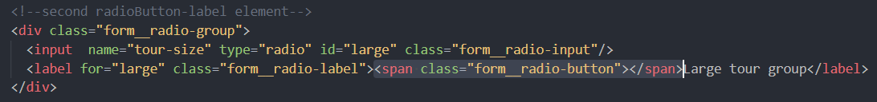

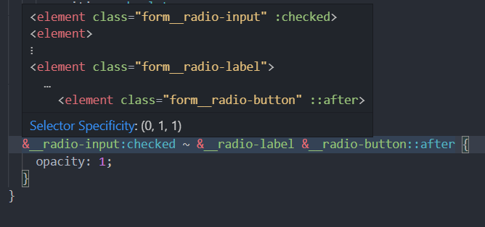

What the selector above does

1.Target the element with the **__radio-input** class that is in a **:checked** state

2. target the first **sibling** that you find with the class of **__radio-label**, of said checked element

3.Target the **siblings**(2.’s) child element with the class of **form__radio-button**

4.Then target its (3.’s) **::after** pseudo element

*Or in the reverse order:*

Target the **(1**)**afte**r pseudo element of an **(2**)element that has a class of **__radio-button** and is a child of an **(3)**element with the class **__radio-label** that has a **(4**)sibling in a (**checked** stateAnd a class of **__radio-input**)

Remember here, that you select child elements (most notably when you are familiar with their class name) from a parent element by ordering them one after the other without commas in this way:

**parent child grandchild greatGrandchild _||_ {…declarationBlock..;}**

**Just the code:**

 &__radio-group {

    width: 49%;

    display: inline-block;

  }

  &__radio-input {

    display: none; //Makes the default radio button disappear

  }

  &__radio-label {

    font-size: $default-font-size;

    cursor: pointer;

    position: relative;

    padding-left: 5rem;

  }

  &__radio-button {

    height: 3rem;

    width: 3rem;

    border: 5px solid $color-primary;

    border-radius: 50%;

    display: inline-block;

    position: absolute;

    left: 0;

    top: -0.4rem;

    //remember that for the pseudo element(after/before) to be visible

    //we have to define a content and display property value

    &::after {

      content: ""; //required

      display: block; //required

      height: 1rem;

      width: 1rem;

      border-radius: 50%;

      background: $color-primary;

      transition: opacity 0.2s;

      //Making it positioned exactly on the center of the parent

      position: absolute;

      top: 50%;

      left: 50%;

      transform: translate(-50%, -50%);

      opacity: 0;

    }

  }

  &__radio-input:checked ~ &__radio-label &__radio-button::after {

    opacity: 1;

  }

     <!--Radio Buttons-->

                <div class="form__group">

                  <!--first radioButton-label element-->

                  <div class="form__radio-group">

                    <input name="tour-size"  type="radio" id="small" class="form__radio-input" />

                    <label name="tour-size" for="small"  class="form__radio-label">

<span class="form__radio-button"></span>Small Tourgroup

</label >

                  </div>

                </div>

## How to animate “solid-color gradients”

### 

### Animating links using a “solid color gradient” and background-size, background-position properties

On hover there appears a background change animation from right to left, changing the background color of the hovered or active element to white. In the following code, we will see exactly how to create this effect.

&__link {

    &:link,

    &:visited {

      display: inline-block; //Only now the padding will be applied

      //Also, only inline-blocks can have transforms applied to them

      font-size: 3rem;

      font-weight: 300;

      padding: 1rem 2rem;

      color: $color-white;

      text-decoration: none;

      text-transform: uppercase;

      background-image: linear-gradient(120deg, transparent 0%, transparent 50%, white 50%);

      background-size: 225%;

      transition: all 0.3s ease-in;

    }

    &:hover,

    &:active {

      background-position: 100%; //works just like translate on X-axis

      color: $color-primary;

      transform: translate(1rem);

    }

    //So the background behind the links is set to be two tone

    //using the solid color gradient. So the left side  of the background

    //image on our links is transparent and the right is white.

    //What we want to do is basically increase the size of the

    //background until the only the transparent parts are visible over

    //the links, and the white parts of the background are overflowing behind

    //the link elements, and so remain invisible.

    //Then, on hover, we want our background to move to the left,

    //in a way positioning the white part of the two tone background over our elements

    //and the way we do this is by using the "background-position: 100%;

    //property, which basically moves the background horizontaly by 100% of its elements width

    //Now our background was set to be 220% of the size of our link element

    //That meanst that background-position:100%; will be moving our actual background halfway to one side

    //The left side, to be precise. This means that now, the right-white side of the background

    //is over our links

    //To recap: 1.Two tone color our background using  solid color gradient (transparent, white)

    //2.Make the background twice as large as our links (background0size: 220%)

    //so that the colored part is outside of our link elements(invisible)

    //3.On hover Using the background-position property, move the background by a 100% of the width of the element

    //placing the white background now over our links

    //Animate the background-position transition, and voila, you have a working

    //animated background overlay effect

## Creating the animation for our nav element

Basicailly what we have here is a circle(green background) behind a circle(of a white background), with the exception that the navigation button has an absolutely positioned navigation background behind it, both are a circle, but the navigation background is a slightly smaller circle positioned right underneath the white nav—button.

When we click the nav button(which is basically a label connected to a checkbox) the checkbox changes into a checked state, and for that checked state, we have created a style that basically scales up the green background nav background 80 times scale(80) so that it completely covers the viewport, and maintaining a fixed position we’ve previously given it, stay on the viewport until the check box is in an un-checked state.

Because the background is a circle (same width, height and a border-radius of 50%) scaling it up, from behind the nav button, creates the illusion of the circle expanding from underneath the nav button and over the screen, (the nav stays visible because it has a z-index larger than the background) The nav list elements have a z index larger than the background as well, and the background has a z-index larger than any other element on the page, save the nav button and list. So that it always overlays

**Note that the label connected to the now invisible checkbox on whose checked state we style the nav__background is basically styled into the white button on the right corner and given a class of nav__button. So the label connected to the checkbox is visually our navigation button**

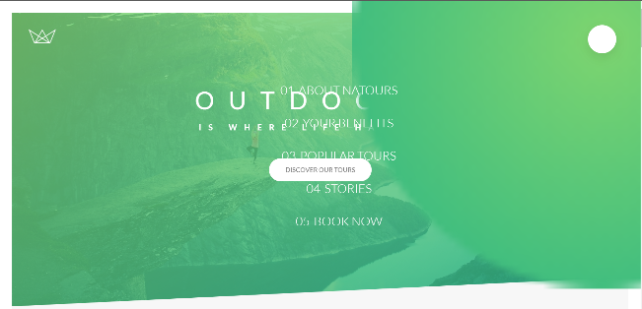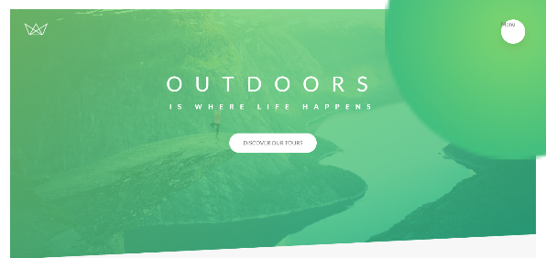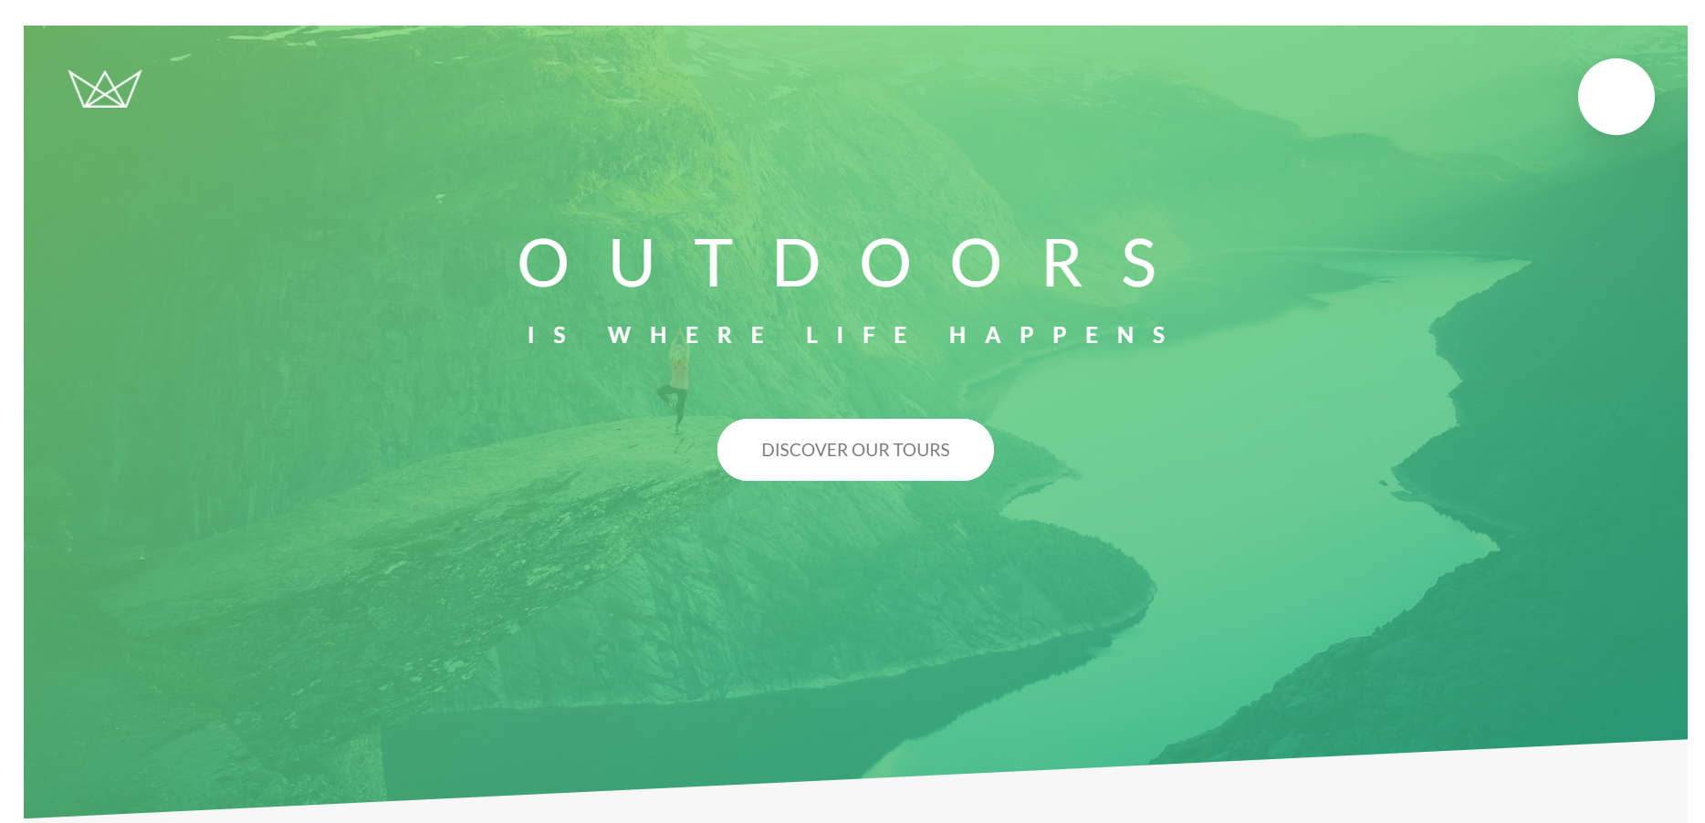

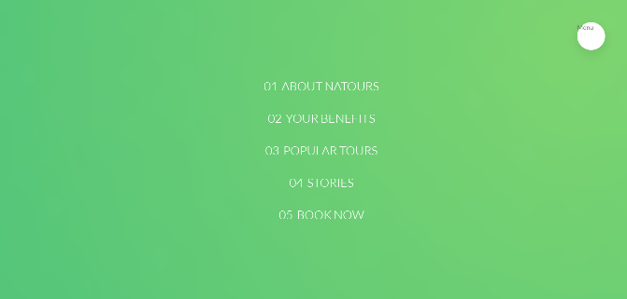

.navigation {

  &__checkbox {

    display: none; //hiding the default checkbox

  }

  &__button {

    background-color: $color-white;

    //We are making the button larger than the background in order

    // to make the background not show (peek) behind it.

    height: 7rem;

    width: 7rem;

    position: fixed;

    top: 6rem;

    right: 6rem;

    border-radius: 50%;

    box-shadow: 0 1rem 3rem rgba($color-black, 0.1);

    z-index: 2000; //higher z-index to go over its background

  }

  //Styling the circular background of our nav-bar toggle button

  &__background {

    height: 6rem;

    width: 6rem;

    border-radius: 50%;

    position: fixed;

    top: 6.5rem;

    right: 6.5rem;

    background-image: radial-gradient($color-primary-light, $color-primary-dark);

    z-index: 1000; //Works only on elements that have a defined position

    transition: all 10s cubic-bezier(0.83, 0, 0.17, 1); //ANIMATION

    //transform: scale(80); //placehodler location

  }

  //Nav contains our list with nav bar clickable links

  &__nav {

    height: 100vh; //100% of the viewport (if it was 100% it would mean of the parent)

    //positioning the nav over the entire screen

    position: fixed; //makes the nav always display on screen

    //Make the element start at the begining of the screen

    top: 0;

    left: 0;

    z-index: 1500;

    //More visible than the background, less visible than the button

    //So the button background is hidden, but the button is visible in the nav

    //--Setting the initial state to the background to disappear

    opacity: 0; //this makes the elements invisible but clickable and still on screen

    width: 0; //this removes the nav elements from the screen completely

    transition: all 10s cubic-bezier(0.34, 1.56, 0.64, 1);

  }

  &__list {

    //centering the list inside the nav container

    position: absolute;

    top: 50%;

    left: 50%;

    transform: translate(-50%, -50%);

    list-style: none;

    text-align: center;

    width: 100%;

  }

  &__item {

    margin: 1rem;

  }

  &__link {

    &:link,

    &:visited {

      display: inline-block; //Only now the padding will be applied

      //Also, only inline-blocks can have transforms applied to them

      font-size: 3rem;

      font-weight: 300;

      padding: 1rem 2rem;

      color: $color-white;

      text-decoration: none;

      text-transform: uppercase;

      background-image: linear-gradient(120deg, transparent 0%, transparent 50%, white 50%);

      background-size: 225%;

      transition: all 0.3s ease-in;

    }

    &:hover,

    &:active {

      background-position: 100%; //works just like translate on X-axis

      color: $color-primary;

      transform: translate(1rem);

    }

    span {

      display: inline-block;

      margin-right: 1rem;

    }

  }

  //The checkbox hack

  //Using the label linked to the checkbox to check/uncheck the now invisible checkbox

  //So that we can, based on the checkbox state(modified by clicking the label)

  //change the style of the element(in this case, the nav menu button, and display of the nav

  //when the checkbox is checked

  //If the checkbox is checked, select the background sibling and apply these rules

  &__checkbox:checked ~ &__background {

    transform: scale(80); //displays the nav background overlay over the whole viewport

  }

  &__checkbox:checked ~ &__nav {

    //Displays the nav elements(links)

    opacity: 1; //makes them visible

    width: 100%; //makes them have their full default clickable size

  }

}

<div class="navigation">

      <input type="checkbox" id="navi-toggle" class="navigation__checkbox" />

      <label for="navi-toggle" class="navigation__button"></label>

      <div class="navigation__background">&nbsp;</div>

      <nav class="navigation__nav">

        <ul class="navigation__list">

          <li class="navigation__item">

            <a href="#" class="navigation__link"><span>01</span>About Natours</a>

          </li>

          <li class="navigation__item">

            <a href="#" class="navigation__link"><span>02</span>Your benefits</a>

          </li>

          <li class="navigation__item">

            <a href="#" class="navigation__link"><span>03</span>Popular tours</a>

          </li>

          <li class="navigation__item">

            <a href="#" class="navigation__link"><span>04</span>Stories</a>

          </li>

          <li class="navigation__item">

            <a href="#" class="navigation__link"><span>05</span>Book now</a>

          </li>

        </ul>

  </nav>

 </div>

## Creating the three-bar animated nav-icon



Basically the three bars separate further on hover, and when the nav menu opens (the button is checked) the top two bars criss cross in an icredibly cool and spiffy animation, and the middle bar dissappears by becoming transparent.

This effect seems pretty straightforward, though there are some 100lines of code required to make this happen. Namely The middle bar is a an empty <span “nav__icon”> element with a ::before and ::after pseudo elements styled to look exactly like it does(making them together into three bars). That span (icon) element is placed inside the nav__button <label> element and so is easily positioned on the button using absolute positioning, also, that parent <label nav__button) is connected to the nav__checkbox. When the checkbox is checked we transform the three bars from paralel to an X. by rotating the top ::before and bottom ::after element 40degrees relative their current position, and making the middle element transparent.

Remember that when you work with pseudo element, display:non of their non-pseudo parent, or width/height/position changes, affect the pseudo elements as well.

WhenThis animation is mainly free spirited experimentation until the effect is just right. Try out the code below, and you’ll see how cool it turns out.

  //##NAVIGATION ICON###

  &__icon {

    position: relative;

    margin-top: 3.5rem;

    //Defining the shared style between

    //the icon line and it's before/after pseudo elements

    &,

    &::before,

    &::after {

      z-index: 50000;

      width: 3rem;

      height: 2.5px; //we don't want the height of our nav lines ever to change

      background-color: $color-gray-dark-3;

      display: inline-block; //we want them all to display as inline blocks

    }

    //Defining the shared position property between pseudo-lines

    &::before,

    &::after {

      content: ""; //content needs to be defined for the two pseudo lines

      position: absolute;

      display: inline-block;

      left: 0;

      transition: all 0.2s;

    }

    //positioning the top pseudo line

    &::before {

      top: -0.8rem;  //moving it above the reference icon-line

    }

    &::after {

      bottom: -0.8rem; //moving it below the reference icon-line

    }

  }

  &__button:hover &__icon::before {//This simple selector is possible because the icon is a child elementof the button

    top: -1rem;

  }

  &__button:hover &__icon::after {

    bottom: -1rem;

  }

  //If the box is checked get the button sibling and target it's child-icon's after element

  &__checkbox:checked ~ &__button &__icon::after {

    transform: rotate(220deg);

    //We want them to rotate 40deg from where they are

    //But before they stop at the 40deg angle, we want them to rotate 180deg

    //So it looks super flashy!

    top: 0;

    bottom: 0; }

  &__checkbox:checked ~ &__button &__icon::before {

    transform: rotate(-220deg);

    top: 0;

    bottom: 0;

  }

  &__checkbox:checked ~ &__button &__icon {

    background-color: transparent;   //If we change the size or position of this icon element

    //we will also change the size of the before and after elements

    //We don't want to do that, as that complicates things

    //So instead of changing the icon element, we simply make it disappear

    //by turning it transparent

  }

}

 <div class="navigation">

      <input type="checkbox" id="navi-toggle" class="navigation__checkbox" />

      <label for="navi-toggle" class="navigation__button">

        <span class="navigation__icon">&nbsp;</span>

      </label>

## How to build a nice popup with only CSS

## How to create boxes with equal height using display:table-cell;



Basically, when we have a box where we wish to have two divs of the same height, what we can do to make the browser do just that implicitly is to set the parent box to **display:table;** and the child div elements to **display:table-cell;** making them a cell within a table element. Doing so will make the browser automatically assign them the same height, so we don’t have to fiddle a lot doing that manually.

 Parent.{

 display: table;

  }

  &__left {

    width: 33.333333333%;  //1 third of the container

    display: table-cell;

  }

  &__right { //2 thirds of the container

    width: 66.6666666667%; //To make the left and right element roughly 100%

    display: table-cell;

    vertical-align: middle;

  }

  &__img {

    display: block;

    width: 100%; //makes them the parent container width

  }

  &__text {

    width: 100%;

    display: inline-block;

  }

Hot to use the :target pseudo-class;

## How to create CSS text columns

    //Creating text columns

.text-container{

    column-count: 2;

    column-gap: 4rem; //default 1em --> font size of the current element

    column-rule: 1px solid $color-gray-2;

}

**Column-count 🡪** how many columns we want to separate our text into

**Column-gap 🡪** how large the space between the column should be

**Column-rule 🡪** The line between the columns (optional) color and style (just like a border)

## How to automatically hyphenate words using hyphens

It is a pretty modern/relatively new tool (as of 2017) so it needs plenty of prefixes in order to work on all modern browsers.

**hyphens: auto;**

Automatically sets the hipyhens (text-break lines) whenever a word breaks into a new line, just note that for hyphenating to work properly, you actually have to define a language for the website (so your browser recognizes the words it is supposed to hyphen)

<html lang="en">

English if you wish to hyphenate english, and Serbian or other language, if you want your browser to hyphenate text in another language. Note how Column rules and hyphen rules are relatively new, so we need to use prefixes to make them work in all browsers

   -moz-column-count: 2;

    -moz-column-gap: 4rem; //default 1em --> font size of the current element

    -moz-column-rule: 1px solid $color-gray-2;

    -ms-hyphens: auto; //ms explorer - or ms edge

    -moz-hyphens: auto;

    -webkit-hyphens: auto; //chrome and safari

## Opening our pop-up using anchoring

Basically, we can create ID’s for elements, and then have our <a> tags (anchors) have in their href=attribute the #+Id-value, so that on click, that anchor transports us to the target element.

In other words, you can imagine, that one element can throw it’s ID as an anchor, to many <a> elements, anchors if you will. (Those <a> element anchors are all connected to that single element, called **the target element**

By using <a class=”button”> anchor tags targeting our pop-out window, we can make the window appear/disappear on the click of the anchor button. This is why we generally use anchors as buttons instead of using buttons, as they have the ability anchor and return us to their target elements using the passed element ID contained in their href attribute.

### **Making the pop-up element invisible**

**Display:none;**  is not the best way to make elements that we want to reappear, disappear, because we simply cannot animate **display** property. We can only animate(transition) porperties that have values passed to them, more specifically numbers of units.Those units can be animated, as they represent iterating increments from current state to target state, and making the transition between the two visible.

In short

WE CANNOT ANIMATE THE DISPLAY PROPERTY SO WE MAKE OUR ELEMENT DISSAPEAR DIFFERENTLY

The solution:

  //making the element hidden until button clicked

    opacity:0;

    visibility: hidden;

opacity is for animating

visibility: hidden; makes the element dissappear from the normal page flow, so that it cannot be clicked or stop us from clicking elements it is overlayed over.

**Anchoring our popup**

<a href="#popup" class="btn btn--white">Book now!</a>

.popup {

  position: fixed;

  top: 0;

  left: 0;

  height: 100vh;

  width: 100vw;

  background-color: rgba($color-black, 0.8);

  z-index: 5000;

  //making the element hidden until button clicked

  opacity: 0;

  visibility: hidden;

  //Animating the popup

  transition: all 0.5s;

  //.popup:target

  &:target {

    opacity: 1;

    visibility: visible;

  }

}

So how anchoring our popup works is that we want our popup style (that makes the popup visible) to take over when the popup itself is the target of a link click. So what happens is that we click on the link, and as our popup element becomes the target of the link and the element’s **:target** state is active the popup appears (its visibility and opacity are turned back on(off in the regular element state).

Now there is only ever one target at a time, in the browser, so each time we press a link the browser sets the target state to a new element. So the way we make the popup disappear is to simply make the **:target** state styles no longer valid for said element. The target state for our popup is not going to be valid (it will be no longer set on the popup element) the moment we follow another link by pressing an anchor tag <a> that is anchored to another element, since that gives the tag’s anchor element the current **:target** state, making our **.popup** element no longer a target, and so, the **:target** rules declared for the **popup** element no longer apply to it. In this case, making any other element a target makes our popup disappear, as it only appears (is set to become visible) if it is a target.

In our popup window, we have set a .popup__close <a> element, and given it the anchor href value to reference the ID of the TOURS section. This changes the target element to #tours, so the #popup is no longer target, and this makes our popup no longer visible.

### What to do if you need to implement two transforms on a single element?

You well know that an element may only have one transform property at a time. Well, you can delcare as many as you want, but only one will get calculated as it wins out in the cascade.

Sometimes (basically when we use mixins and xtends) it happens that we cannot simply add a new transform value to our original transform, because changing the mixin will change it for all elements that implement that mixin.

What we have to do in that case, is copy the exact transform poperty values that we’ve already had, and add our desired new value, and place that at the bottom of the css/sass declaration block for that element. That way, only the last transform rule will get calculated, and that will be okay, because we placed all of the same values from our previous transform(so it will act in the same way) plus added a new value, that we wanted to additionally implement.

&__content {

    @include absCenter; //Absolute center mixin:

    //position: absolute;

    //top: 50%;

   // left: 50%;

// transform: translate(-50%, -50%);

    width: 75%;

    background-color: $color-white;

    box-shadow: 0 2rem 4rem rgba($color-black, 0.2);

    z-index: 5500; //has to have a larger index than dark background

    border-radius: 3px;

    //making the images not overflow over our border radius

    overflow: hidden;

    //Making the container act as a table

    //and children containers act as cell

    display: table;

    //Defining the initial (un-poped state) of our popup content card

    opacity: 0;

    transform: translate(-50%, -50%) scale(0.5);

//repeating the original transform and adding to it a scale value

  }

### **Creating the pop-up animation for our popoup box container**

## Complete Code for the CSS popup window

.popup {

  position: fixed;

  top: 0;

  left: 0;

  height: 100vh;

  width: 100vw;

  background-color: rgba($color-black, 0.8);

  z-index: 5000;

  //Making the element hidden before it pops up

  opacity: 0;

  visibility: hidden;

  //Animating the popup

  transition: all 0.5s;

  &__content {

    @include absCenter; //Absolute center mixin

    position: absolute;

    top: 50%;

    left: 50%;

    transform: translate(-50%, -50%);

    width: 75%;

    background-color: $color-white;

    box-shadow: 0 2rem 4rem rgba($color-black, 0.2);

    z-index: 5500; //has to have a larger index than dark background

    border-radius: 3px;

    //making the images not overflow over our border radius

    overflow: hidden;

    //Making the container act as a table

    //and children containers act as cell

    display: table;

    //Defining the initial (un-poped state) of our popup content card

    opacity: 0;

    transform: translate(-50%, -50%) scale(0.25);

    transition: all 0.5s 0.2s; //added .2s delay

    //so overlay first appears, then our element starts working

  }

  //1 third of the container

  &__left {

    width: 33.333333333%;

    display: table-cell;

  }

  //2 thirds of the container

  &__right {

    width: 66.6666666667%; //To make the left and right element roughly 100%

    display: table-cell;

    vertical-align: middle;

    padding: 3rem 5rem;

  }

  &__img {

    display: block;

    width: 100%; //makes them the parent container width

  }

  &__text {

    font-size: 1.4rem;

    margin-bottom: 4rem;

    //Creating text columns

    -moz-column-count: 2;

    -moz-column-gap: 4rem; //default 1em --> font size of the current element

    -moz-column-rule: 1px solid $color-gray-dark-2;

    -ms-hyphens: auto; //ms explorer - or ms edge

    -moz-hyphens: auto;

    -webkit-hyphens: auto; //chrome and safari

    //automatically sets the hipyhens (text-break lines) whenever a word breaks into a new line

  }

  //DEFINING THE POPUP - OPEN states

  //.popup:target

  &:target {

    opacity: 1;

    visibility: visible;

  }

  //Animating the content child element of the child element

  //so that it pops out to the screen when the popup becomes the target

  &:target &__content {

    opacity: 1;

    transform: translate(-50%, -50%) scale(1);

    //Making sure to keep the translate values from our mixin

  }

  //CLOSE BUTTON

  &__close {

    &:visited,

    &:link {

      color: $color-gray-dark;

      position: absolute;

      top: 2.5rem;

      right: 2.5rem;

      font-size: 3rem;

      text-decoration: none;

      display: inline-block;

      transition: all 0.2s;

      line-height: 1;

      &:hover {

        color: $color-primary;

      }

    }

  }

}

 <!--##POPUP##-->

    <!--Dark popup bakround-->

    <div class="popup" id="popup">

      <!--Content Box-->

      <div class="popup__content">

        <!--Left popup element-->

        <div class="popup__left">

          <img class="popup__img" src="images/nat-8.jpg" alt="Tour Photo" />

          <img class="popup__img" src="images/nat-9.jpg" alt="Tour Photo" />

        </div>

        <!--Right popup element-->

        <div class="popup__right">

          <!--Close button-->

          <a href="#section-tours" class="popup__close">&times;</a>

          <h2 class="heading-secondary utility-margin-bottom-smalll">Start booking now</h2>

          <h3 class="heading-tertiary utility-margin-bottom-small">Important &ndash; Please read these terms before booking</h3>

          <p class="popup__text">

            Lorem ipsum dolor sit, temporibus optio quos rerum? Quidem harum sunt inventore perspiciatis.amet consectetur adipisicing elit. Inventore,

            maiores sed nesciunt exercitationem quam explicabo magnam earum aspernatur dicta nulla consectetur odit quos officiis

            consequatur,temporibus optio quos rerum? Quidem harum sunt inventore perspiciatis. necessitatibus ea pariatur veniam voluptatibus. Lorem,

            ipsum dolor sit amet consectetur adipisicing elit. Est doloribus autem beatae cumque aut provident earum cupiditate, voluptatibus porro,

            perspiciatis ad temporibus optio quos rerum? Quidem harum sunt inventore perspiciatis.

          </p>

          <a href="#" class="btn btn--green">Book now</a>

        </div>

      </div>

    </div>

### **The final popup look ^_____^**

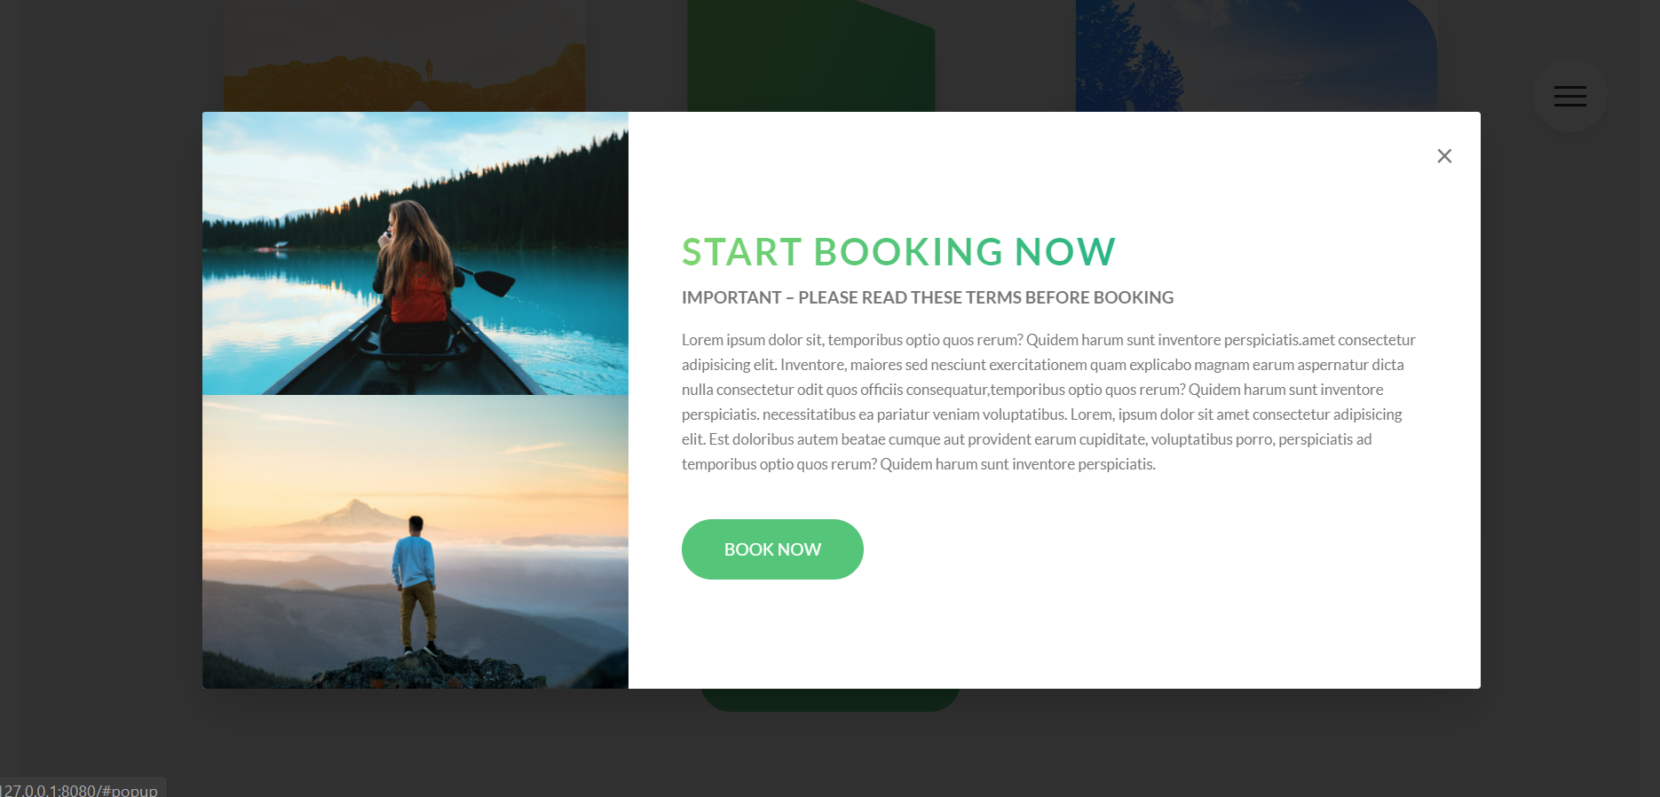

## Creating responsive layout elements

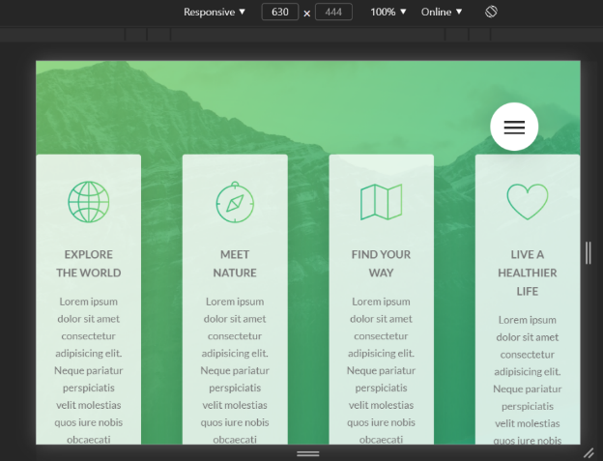

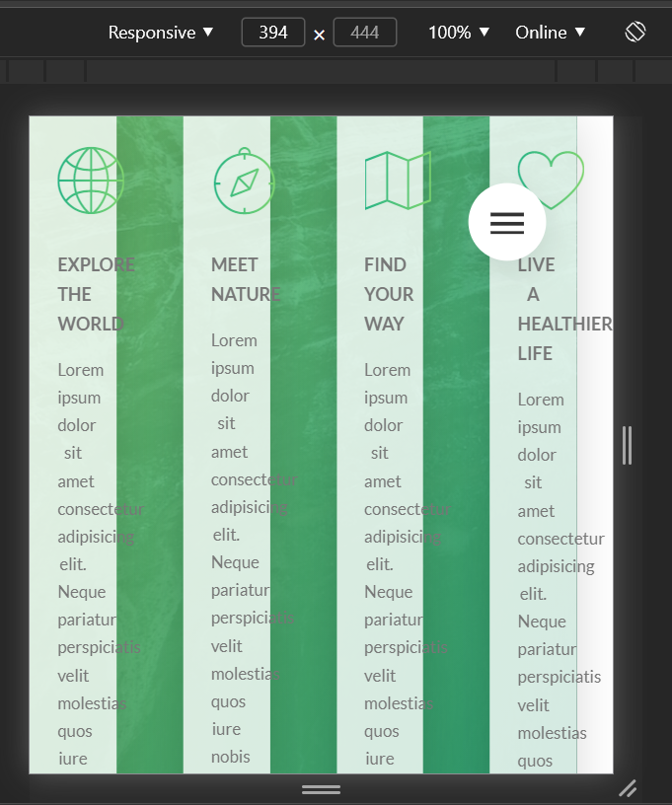

For the natours project, we’ve used a floating-grid layout system, creating rows in our sections and inserting elements into the row’s columns. Above we can see a row with four column-1-of-4. Representing a row with four columns, where each column is the same size.

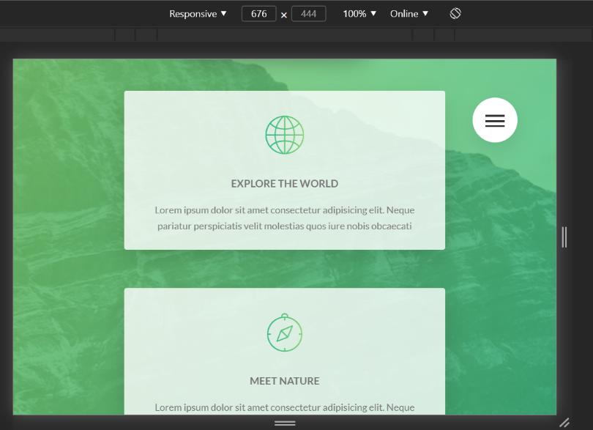I don’t have to say that we don’t want to have our elements (their column containers actually) squashed up like this. So how this situation is usually fixed in our layout elements is by simply giving each column a width of 100%. So that means that the column get’s a width of 100% of its parent row, meaning that we’ve essentially turned our columns into rows. So a row of columns would in this case become a row of four rows stacked on top of each other.

On the right is our desired layout for smaller screens. 🡪

**Let’s see how this looks in practice:**

.row {

  max-width: $grid-width; /*1140px*/

  margin: 0 auto; /*trick to center one block element inside another block element*/

  //Setting up the gutter between the rows

  &:not(:last-child) {

    margin-bottom: $gutter-horizontal;

    //Media query

    @include respond(tab-port) {

      margin-bottom: $gutter-horizontal-small;

    }

  }

  //Media query (making the elements not spread out over all avaliable space

  // when max-width is not reached, by making the max width smaller

  @include respond(tab-port) {

    max-width: 50rem;

  }

  //Insert clearfix before our columns

  @include clearfix; //.row::after{clearfix-content}

  //ATTRIBUTE SELECTOR sellects all columns, floats them and

  //adds a right margin(gutter) to all but the last column

  [class^="column-"] {

    float: left;

    //Setting up the gutter between the columns

    //gives a margin-right to all columns except the last(child)one

    &:not(:last-child) {

      margin-right: $gutter-vertical;

      //Media query

      @include respond(tab-port) {

        margin-right: 0;

        margin-bottom: $gutter-horizontal-small;

      }

    }

    //MediaQuery

    @include respond(tab-port) {

      width: 100% !important; //column becomes as wide as it's parent row(turns into row)

      //has to be important to make sure the more specific

      //column width rules that follow don't overwrite this media query

    }

  }

### **Before adding changing max-width in a media query vs after**

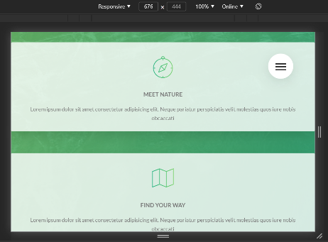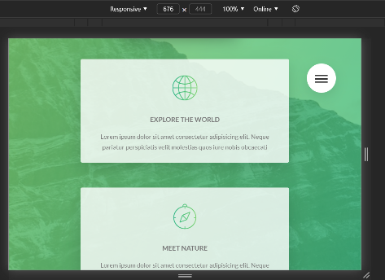Max width works in the following manner, if our viewport is smaller than the set max-width, the element will take up as much space as is currently available in the viewport.

On the other hand, If the viewport is larger then the set max-width of the element, it will remain at the max-width value

Here, we’ve shrunk the viewport, which means that the rows containing our card elements here, are smaller than their default max width. This makes them take up all the available horizontal space, as max width does.

To combat this, we set a lower threshold for the **max-width** so that the new max width is smaller then the device viewport width where we have this problem of our column elements taking up the entire horizontal space. And voila, the problem is solved

.row {

  max-width: $grid-width; /*1140px*/

  margin: 0 auto;

  //Setting up the gutter between the rows

  &:not(:last-child) {

    margin-bottom: $gutter-horizontal;

    //Media query

    @include respond(tab-port) {

      margin-bottom: $gutter-horizontal-small;

    }

  }

  //Media query (making the elements not spread out over all avaliable space

  // when max-width is not reached, by making the max width smaller

  @include respond(tab-port) {

    max-width: 50rem;

  }

## Creating LINEAR GRADIENT inside TEXT

1.First we add a linear gradient background, making sure that the background is only as wide as the text, by specifying **display:inline-block;** property.

background-image: linear-gradient(

*to* right,

    $color-primary-light,

    $color-primary-dark

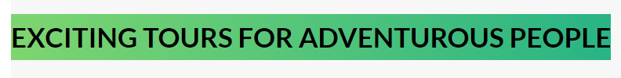

2.Then we clip the background to the text (so that the background around the text gets cropped off) so that the background now only exists behind our text (individual letters/characters)

-webkit-background-clip: text;



3.Adding a transparent color to our text: Since our background now dissapeared behind our black text color, we want to make it visible. To do this we simply have to make the text transparent and the gradient behind the characters will become visible, e-voilla:

 color: transparent;



**The full style: declaration block**

.heading-secondary {

  display: inline-block;

  font-size: 3.5rem;

  text-transform: uppercase;

  font-weight: 700;

  /*Making the text have a linear gradient */

  background-image: linear-gradient(

*to* right,

    $color-primary-light,

    $color-primary-dark

  );

  -webkit-background-clip: text;

  color: transparent;}

## How absolute positioning works (REVISITED)

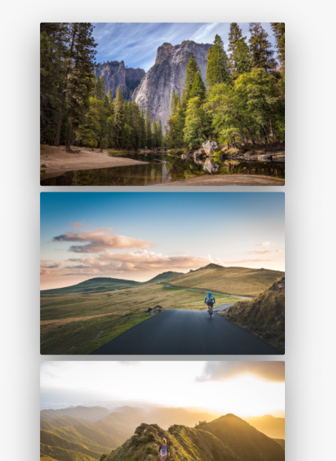Basically an absolute positioned element, is a position that is relative to a referenced element. (relative is a position relative to the page, absolute is a position relative to a referenced element)

This referenced element is by default the first encountered parent element that has the **position-property set to something (absolute/relative)**.

Note that by default the absolutely positioned elements, will appear on the 0x 0y coordinates of the parent element. Or better stated the 0x 0y coordinate of the absolute element will get positioned on the 0x 0y coordinate of a **positioned(relatively/absolutely) parent element.**

How that looks in practice. The absolute elements top most left position will appear on the parent’s **top: 0; left:0;**  positon, unless otherwise stated.

It is for the reason of reference, that we give the parent element of an absolutely positioned element the **position: relative;** property value.

 <div class="column-1-of-2">

            <div class="composition">

              <img

                src="images/nat-1-large.jpg"

                alt="Image 1"

                class="composition__photo composition__photo--p1"

              />

              <img

                src="images/nat-2-large.jpg "

                alt="Image 2"

                class="composition__photo composition__photo--p2"

              />

              <img

                src="images/nat-3-large.jpg "

                alt="Image 3"

                class="composition__photo composition__photo--p3"

              />

            </div>

**Before the absolute positioning(images were left/top of each other(depending on space)**

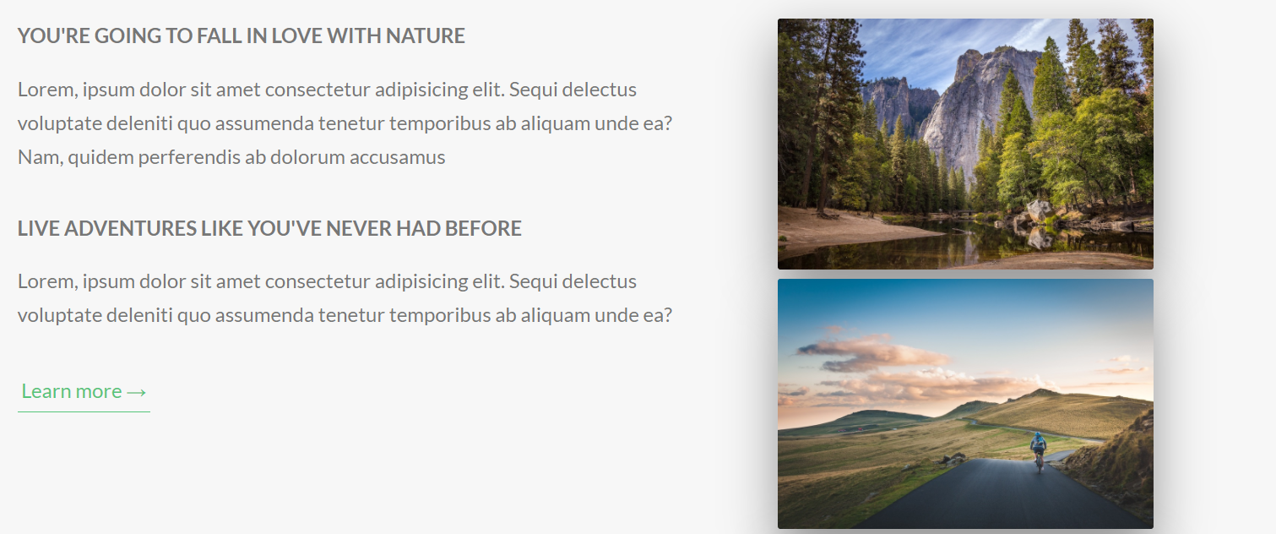

.composition {

Position: relative;

  &__photo {

    width: 55%;

    box-shadow: 0 1.5rem 4rem

rgba($color-black, 0.4);

    border-radius: 2px;

    position: absolute;

  }

**After being positioned absolute (notice that the images are now on top of each other)**

## 

#### **Scaling images and positioning elements (aside)**

**Note: You should, whenever possible, define the width of images in percentages, in order to keep the images responsive, so that they will nicely scale with the viewport.**

**The same thing applies to positioning elements, it is best to use % when positioning your elements. So that they always scale with your viewport**

## Scaling other images on the hover of one element

.composition {

  position: relative;

  transition: all 0.3s;

  &:hover &__photo:not(:hover) {

    transform: scale(0.98);

  }

  &:hover &__photo:not(:hover) {

    transform: scale(0.98);

  }

When you hover over the parent (.composition) class, only then target .composition__photo class elements, and if they don’t have a hover pseudo class over them  transform: scale(0.98);

This effectively has a selector that only gets activated on hover of it’s parent

parent:hover &thenSelect:

**.composition:hover .composition__photo:not(:hover){…}**

### **Creating a border(OUTLINE) with the image separated from the outline**

Here we can see that the image displayed is not actually touching the outline. For this we’ve simply used the outline property on **hover** to make the outline display with the width and color that it has. While on the original element we’ve set the **outline-offset** property to define how much we want our element to be apart(separated from the outline)

Bellow is the shorthand for the relevant parts of the code:

  &__photo {

    outline-offset: 2rem; /*20px*/

    // .composition__photo:hover

    &:hover {

      outline: 1.5rem solid $color-primary;

## **MEDIA QUERY MANAGER 🡪 SASS**

//MEDIA QUERY MANAGER

//0 -600px:  Phone

//600-900px: Tablet portrait

//900-1200px: Tablet landscape

//[1200- 1800] is where our normal styles apply

// 1800px +: Big desktop

/*

   $breakpoint argument choices:

   - phone

   - tab-port

   - tab-land

   - big-desktop

  */

@mixin respond($breakpoint) {

  //Our mixin manager checks what breakpoint parameter

  //text is included, and applies only the mixin content

  //that corresponds to one of the four available breakpoints

  //Device with (px) converted to em by dividing px-value /16

  @if $breakpoint == phone {

    @media (max-width: 37.5em) {

      //apply on devices lesserless than 600px

      @content;

    }

  }

  @if $breakpoint == tab-port {

    @media (max-width: 56.25em) {

      //apply on devices lesserless than 900px

      @content;

    }

  }

  @if $breakpoint == tab-land {

    @media (max-width: 75em) {

      //apply on devices lesser than 1200px

      @content;

    }

  }

  @if $breakpoint == big-desktop {

    @media (min-width: 112.5em) {

      // apply on devices  of 1800px or more

      @content;

    }

  }

}

/*Performing the basic reset*/

html {

  //This defines what 1rem is

  //if 1rem = 10px then the percentage of 16px(100%)

  //is (100/16)*100 = 62.5%

  font-size: 62.5%; /*62.5% of ( 100% == 16px) is 10px */

  @include respond(tab-land) {

    //width < 900px

    font-size: 56.25%; //we want 1rem  to be 9px   (9/16px)*100 = 56.25%

  }

  @include respond(tab-port) {

    //width<600px

    font-size: 50%; //we want 1rem = 8px   (8/16px)*100 = 50%

  }

  @include respond(big-desktop) {

    font-size: 75%; //we want 1rem to be 12px (12/17)*100 = 75%

  }

}

## Trillo user-reviews(COMPONENT)

 <!--USER REVIEWS-->

            <div class="user-reviews">

              <!--A User Review-->

              <figure class="review">

                <blockquote class="review__text">

                  Lorem ipsum, dolor sit amet consectetur adipisicing elit. Praesentium necessitatibus molestiae, pariatur, fuga, consequuntur

                  asperiores dolorum nobis qui fugiat ducimus nulla tempore voluptatum.

                </blockquote>

                <figcaption class="review__user">

                  <img src="img/user-1.jpg" alt="User 1" class="review__photo" />

                  <div class="review__user-box">

                    <p class="review__user-name">Nick Smith</p>

                    <p class="review__user-date">Feb 23rd, 2017</p>

                  </div>

                  <div class="review__rating">7.8</div>

                </figcaption>

              </figure>

              <!--A User Review-->

              <figure class="review">

                <blockquote class="review__text">

                  Lorem ipsum, dolor sit amet consectetur adipisicing elit. Praesentium necessitatibus molestiae, pariatur, fuga, consequuntur

                  asperiores dolorum nobis qui fugiat ducimus nulla tempore voluptatum.

                </blockquote>

                <figcaption class="review__user">

                  <img src="img/user-2.jpg" alt="User 1" class="review__photo" />

                  <div class="review__user-box">

                    <p class="review__user-name">Mary Thomas</p>

                    <p class="review__user-date">Sept 13th 2017</p>

                  </div>

                  <div class="review__rating">9.3</div>

                </figcaption>

              </figure>

            </div>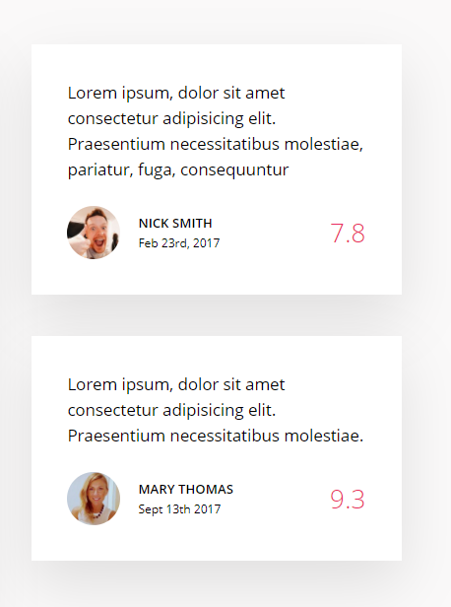

////////////////////////////////////

//////REVIEWS

.review {

  display: flex;

  flex-direction: column;

  justify-content: space-around;

  background-color: #fff;

  box-shadow: var(--shadow-light);

  padding: 3rem;

  margin-bottom: 3.5rem;

  &__text {

    margin-bottom: 2rem;

  }

  &__user {

    display: flex;

    align-items: center; //Vertically align items

  }

  &__photo {

    height: 4.5rem;

    width: 4.5rem;

    border-radius: 50%;

    margin-right: 1.5rem;

  }

  &__user-box {

    display: flex;

    flex-direction: column;

  }

  &__user-name {

    text-transform: uppercase;

    font-size: 1.1rem;

    font-weight: 600;

    margin-bottom: 0.4px;

  }

  &__user-date {

    font-size: 1rem;

    color: var(--color-gray-dark-3);

  }

  &__rating {

    color: var(--color-primary);

    font-size: 2.2rem;

    font-weight: 300;

    margin-left: auto; //making a white space between it and adjacent element

  }

  //CREATING THE LARGE QUOTATION MARKS

  &::before {

    content: "";  }}

## Beoactive user reviews (COMPONENT)

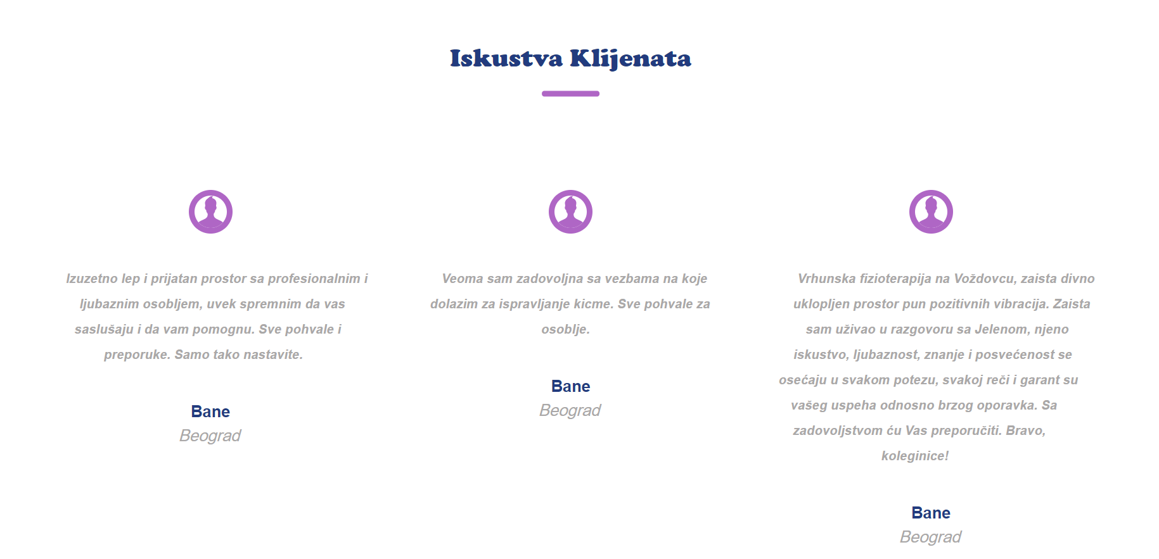

  <!--###SECTION Iskustva-->

    <section class="iskustva">

      <h1 class="heading-primary iskustva__heading">Iskustva Klijenata</h1>

      <!--Container containing reviews-->

      <!--Will be one of 3 flex containers in a slider -->

      <div class="iskustva__flex-container">

        <!--Review box-->

        <figure class="iskustva__iskustvo-box">

          <svg class="icon icon-user">

            <use xlink:href="img/sprite.svg#icon-user"></use>

          </svg>

          <blockquote class="iskustva__text">

            Izuzetno lep i prijatan prostor sa profesionalnim i ljubaznim osobljem, uvek spremnim da vas saslušaju i da vam pomognu. Sve pohvale i

            preporuke. Samo tako nastavite.

          </blockquote>

          <figcaption class="iskustva__korisnik-box">

            <p class="iskustva__ime-korisnika">Bane</p>

            <p class="iskustva__lokacija-korisnika">Beograd</p>

          </figcaption>

        </figure>

        <!--Review box-->

        <figure class="iskustva__iskustvo-box">

          <svg class="icon icon-user">

            <use xlink:href="img/sprite.svg#icon-user"></use>

          </svg>

          <blockquote class="iskustva__text">

            Veoma sam zadovoljna sa vezbama na koje dolazim za ispravljanje kicme. Sve pohvale za osoblje.

          </blockquote>

          <figcaption class="iskustva__korisnik-box">

            <p class="iskustva__ime-korisnika">Bane</p>

            <p class="iskustva__lokacija-korisnika">Beograd</p>

          </figcaption>

        </figure>

        <!--Review box-->

        <figure class="iskustva__iskustvo-box">

          <svg class="icon icon-user">

            <use xlink:href="img/sprite.svg#icon-user"></use>

          </svg>

          <blockquote class="iskustva__text">

            Vrhunska fizioterapija na Voždovcu, zaista divno uklopljen prostor pun pozitivnih vibracija. Zaista sam uživao u razgovoru sa Jelenom,

            njeno iskustvo, ljubaznost, znanje i posvećenost se osećaju u svakom potezu, svakoj reči i garant su vašeg uspeha odnosno brzog oporavka.

            Sa zadovoljstvom ću Vas preporučiti. Bravo, koleginice!

          </blockquote>

          <figcaption class="iskustva__korisnik-box">

            <p class="iskustva__ime-korisnika">Bane</p>

            <p class="iskustva__lokacija-korisnika">Beograd</p>

          </figcaption>

        </figure>

      </div>

    </section>

    <!--Iskustva // SECTION END-->

//////////////////////////////

////SECTION Iskustva

.iskustva .icon {

  // @include iconStyle; //Whole declaration block is a mixin

  fill: var(--color-text-secondary);

  //common practice to size svg's into squares

  width: 5rem;

  height: 5rem;

  border: 6px solid $color-text-secondary;

  border-radius: 50%;

  //to make the SVG icon not display any whitespace

  font-size: 0;

  line-height: 0;

}

.iskustva {

  &__heading {

    position: relative;

    text-align: center;

    margin-bottom: 6rem;

    &:after {

      content: "";

      display: inline-block;

      background-color: var(--color-text-secondary);

      position: absolute;

      top: 200%;

      left: 50%;

      transform: translate(-50%, -50%);

      height: 6px;

      width: 9rem;

      border-radius: 5px;

    }

  }

  &__flex-container {

    position: relative;

    margin: 0 auto;

    padding: 5%;

    display: flex;

  }

  &__iskustvo-box {

    padding: 2%;

    display: flex;

    flex-direction: column;

    align-items: center;

    width: 30%;

    & > *:not(:last-child) {

      margin-bottom: 5rem;

    }

  }

  &__text {

    text-align: center;

    font-size: 0.8em;

    line-height: 4rem;

    font-weight: 700;

    transform: skew(-10deg);

  }

  &__korisnik-box {

    display: flex;

    flex-direction: column;

    align-items: center;

  }

  &__ime-korisnika {

    color: var(--color-background-dark);

    font-weight: 700;

  }

  &__lokacija-korisnika {

    transform: skew(-15deg);

  }

}

## Article Cards (Beoactive website Component)

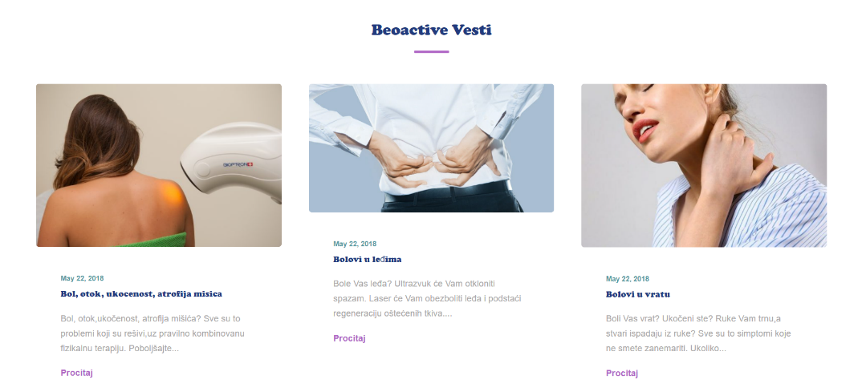

<!--#####VESTI section-start -->

    <section class="vesti">

      <h1 class="heading-primary vesti__heading">Beoactive Vesti</h1>

      <!--Section flexc-container-->

      <div class="vesti__flexbox">

        <!--Card flex item-->

        <figure class="vesti-card">

          <img src="img\BIOPTRON-586x390.jpg" alt="" class="vesti-card__image" />

          <!--Details contain all card text(details)-->

          <div class="vesti-card__details">

            <figcaption class="vesti-card__title-box">

              <p class="vesti-card__title-date">May 22, 2018</p>

              <h2 class="vesti-card__title-heading">Bol, otok, ukocenost, atrofija misica</h2>

            </figcaption>

            <blockquote class="vesti-card__description-text">

              Bol, otok,ukočenost, atrofija mišića? Sve su to problemi koji su rešivi,uz pravilno kombinovanu fizikalnu terapiju. Poboljšajte...

            </blockquote>

            <a href="#" class="inline-button vesti-card__button">Procitaj</a>

          </div>

        </figure>

        <!--Card flex item-->

        <figure class="vesti-card">

          <img src="img\bolovi_u_ledjima.jpg" alt="" class="vesti-card__image" />

          <!--Details contain all card text(details)-->

          <div class="vesti-card__details">

            <figcaption class="vesti-card__title-box">

              <p class="vesti-card__title-date">May 22, 2018</p>

              <h2 class="vesti-card__title-heading">Bolovi u leđima</h2>

            </figcaption>

            <blockquote class="vesti-card__description-text">

              Bole Vas leđa? Ultrazvuk će Vam otkloniti spazam. Laser će Vam obezboliti leđa i podstaći regeneraciju oštećenih tkiva....

            </blockquote>

            <a href="#" class="inline-button vesti-card__button">Procitaj</a>

          </div>

        </figure>

        <!--Card flex item-->

        <figure class="vesti-card">

          <img src="img\bolovi_u_vratu-585x390.jpg" alt="" class="vesti-card__image" />

          <div class="vesti-card__details">

            <figcaption class="vesti-card__title-box">

              <p class="vesti-card__title-date">May 22, 2018</p>

              <h2 class="vesti-card__title-heading">Bolovi u vratu</h2>

            </figcaption>

            <blockquote class="vesti-card__description-text">

              Boli Vas vrat? Ukočeni ste? Ruke Vam trnu,a stvari ispadaju iz ruke? Sve su to simptomi koje ne smete zanemariti. Ukoliko...

            </blockquote>

            <a href="#" class="inline-button vesti-card__button">Procitaj</a>

          </div>

        </figure>

      </div>

    </section>

    <!--VESTI Section-end-->

/////////////////////////

/////VESTI-SECTION

.vesti {

  &__heading {

    position: relative;

    text-align: center;

    margin: 4rem 0 12rem 0;

    &:after {

      content: "";

      display: inline-block;

      background-color: var(--color-text-secondary);

      position: absolute;

      top: 200%;

      left: 50%;

      transform: translate(-50%, -50%);

      height: 4px;

      width: 9rem;

      border-radius: 5px;

    }

  }

  &__flexbox {

    display: flex;

    justify-content: space-around;

  }

}

.vesti-card {

  width: 30%;

  display: flex;

  flex-direction: column;

  align-items: space-between;

  font-size: 0.9em;

  &__image {

    border-radius: 5px;

  }

  &__details {

    //contains all text content

    padding: 10%;

  }

  &__title-box {

  }

  &__title-date {

    font-size: 0.8em;

    font-weight: bold;

    color: var(--color-background-light);

  }

  &__title-heading {

    font-size: 1em;

    color: var(--color-background-dark);

    font-weight: 100;

  }

  &__description-text {

    padding: 5% 0;

  }

  &__button {

  }

}

# BEOACTIVE website template

**HTML 🡪 content**

<html lang="en">

  <head>

    <meta charset="UTF-8" />

    <meta name="viewport" content="width=device-width, initial-scale=1.0" />

    <title>Beoactive</title>

    <!--CSS Links -->

    <link rel="stylesheet" href="css\style.css" />

    <!--Font-icons -->

    <link rel="stylesheet" href="https://cdnjs.cloudflare.com/ajax/libs/font-awesome/4.7.0/css/font-awesome.min.css" />

  </head>

  <body>

    <header class="header">

      <nav class="header__nav">

        <!--First Nav Element-->

        <div class="header__logo-box">

          <img src="img\logo.jpg" alt="" class="header__logo" />

        </div>

        <!--Second Nav Element-->

        <div class="header__items">

          <ul class="header__links">

            <li class="header__item"><a href="#" class="header__link header__link--active">Home</a></li>

            <li class="header__item"><a href="#" class="header__link">O Nama</a></li>

            <li class="header__item"><a href="#" class="header__link">Usluge</a></li>

            <li class="header__item"><a href="#" class="header__link">Cenovnik</a></li>

            <li class="header__item"><a href="#" class="header__link">Kontakt</a></li>

            <li class="header__item"><a href="#" class="header__link">Galerija</a></li>

            <li class="header__item"><a href="#" class="header__link header__link--button button">Rezervisi termin</a></li>

          </ul>

        </div>

      </nav>

    </header>

    <!--INTRO ########section start-->

    <section class="Intro">

      <!--The Section acts as a slide-show container-->

      <!--Slide1-->

      <div class="banner banner--slide-1">

        <div class="banner__content">

          <h1 class="banner__heading">Sportska povreda?</h1>

          <p class="banner__paragraph">

            Nas tim strucnjaka ce savremenim metodama resiti Vase <br />

            probleme.

          </p>

          <a href="" class="banner__button button">Pozovite</a>

        </div>

      </div>

      <!--Slide2-->

      <div class="banner banner--slide-2">

        <div class="banner__content">

          <h1 class="banner__heading">Sportska povreda?</h1>

          <p class="banner__paragraph">

            Rezervisite danas tretman kod naseg iskusnog <br />

            fizioterapeuta i resite svoje svakodnevne probleme

          </p>

          <a href="" class="banner__button button">Rezervisite svoj termin</a>

        </div>

      </div>

      <!--Slide3-->

      <div class="banner banner--slide-3">

        <div class="banner__content">

          <h1 class="banner__heading">Sportska povreda?</h1>

          <p class="banner__paragraph">

            Najefikasniji nacin vezbanja za lecenje skolioza! Vezbanje <br />

            po Schroth metodi, daje najbolje rezultate u tretmanu svih <br />

            zakrivljenja kicmenog stuba probleme.

          </p>

          <a href="" class="banner__button button">Rezervisite svoj termin</a>

        </div>

      </div>

    </section>

    <!--Intro Section End///-->

    <!--#####USLUGE  section-start-->

    <section class="usluge">

      <!--Main section flex container-->

      <div class="usluge__content">

        <!--Flex element1-->

        <div class="usluge__usluga usluge__usluga--sveUsluge">

          <h1 class="heading-primary usluge__heading">Beoactive usluge</h1>

          <p class="usluge__paragraph">

            U Beoactive centru,dostupni su Vam najsavremeniji modaliteti fizikalnih agenasa,upotpunjeni znanjem i iskustvom

            fizioterapeuta.Relaksirajućim masažama i strogo doziranim,individualnim vežbama i treninzima,učinićemo Vaš život lepšim,lakšim i

            kvalitetnijim.

          </p>

          <a href="#" class="usluge__button inline-button">Sve usluge</a>

        </div>

        <!--Flex element2-->

        <div class="usluge__usluga">

          <div class="usluge__image-box">

            <img src="img\MASAŽA2-586x390.jpg" alt="" class="usluge__img" />

          </div>

          <div class="usluge__text-box">

            <h1 class="heading-secondary usluge__heading">Masaza</h1>

            <p class="usluge__paragraph">

              Masaža predstavlja jednu od najpopularnijih terapijskih metoda. Prema nameni, može biti terapijsko-medicinska, sportska,...

            </p>

            <a href="#" class="usluge__button inline-button">Procitaj</a>

          </div>

        </div>

        <!--Flex element3-->

        <div class="usluge__usluga">

          <!--Image-->

          <div class="usluge__image-box">

            <img src="img/ELEKTROTERAPIJA2-586x390.jpg" alt="electrotherapy" class="usluge__img" />

          </div>

          <!--Text-->

          <div class="usluge__text-box">

            <h1 class="heading-secondary usluge__heading">Elektroterapija</h1>

            <p class="usluge__paragraph">

              Elektroterapija predstavlja primenu elektriciteta u terapijske svrhe. U fizikalnoj terapiji, najčešću primenu nalaze:...

            </p>

            <a href="#" class="usluge__button inline-button">Procitaj</a>

          </div>

        </div>

      </div>

    </section>

    <!--Section ZastoBeoactive-->

    <section class="zastoMi">

      <h1 class="heading-primary zastoMi__heading">Zasto Beoactive?</h1>

      <div class="zastoMi__grid">

        <!--Content row -->

        <!--COLUMN(CELL) Icon + description -->

        <div class="zastoMi__column">

          <div class="zastoMi__column-content">

            <svg class="icon icon-user"><use xlink:href="img/sprite.svg#icon-user"></use></svg>

            <h2 class="heading-secondary">Iskusni fizioterapeuti</h2>

          </div>

        </div>

        <!--COLUMN(CELL) Icon + description -->

        <div class="zastoMi__column">

          <div class="zastoMi__column-content">

            <svg class="icon icon-profile"><use xlink:href="img/sprite.svg#icon-profile"></use></svg>

            <h2 class="heading-secondary">Strucni fizioterapeuti</h2>

          </div>

        </div>

        <!--COLUMN(CELL) Icon + description -->

        <div class="zastoMi__column">

          <div class="zastoMi__column-content">

            <svg class="icon icon-office"><use xlink:href="img/sprite.svg#icon-office"></use></svg>

            <h2 class="heading-secondary">Kompletno opremljen centar</h2>

          </div>

        </div>

        <!--Content row-->

        <!--COLUMN(CELL) Icon + description -->

        <div class="zastoMi__column">

          <div class="zastoMi__column-content">

            <svg class="icon icon-truck"><use xlink:href="img/sprite.svg#icon-truck"></use></svg>

            <h2 class="heading-secondary">Besplatan parking</h2>

          </div>

        </div>

        <!--COLUMN(CELL) Icon + description -->

        <div class="zastoMi__column">

          <div class="zastoMi__column-content">

            <svg class="icon icon-heart"><use xlink:href="img/sprite.svg#icon-heart"></use></svg>

            <h2 class="heading-secondary">Personalizovan tretman</h2>

          </div>

        </div>

        <!--COLUMN(CELL) Icon + description  -->

        <div class="zastoMi__column">

          <div class="zastoMi__column-content">

            <svg class="icon icon-spell-check"><use xlink:href="img/sprite.svg#icon-spell-check"></use></svg>

            <h2 class="heading-secondary">Konverzacija na engleskom jeziku</h2>

          </div>

        </div>

      </div>

    </section>

    <!--#####ISKUSTVA section-start-->

    <section class="iskustva">

      <h1 class="heading-primary iskustva__heading">Iskustva Klijenata</h1>

      <!--Container containing reviews-->

      <!--Will be one of 3 flex containers in a slider -->

      <div class="iskustva__flex-container">

        <!--Review box-->

        <figure class="iskustva__iskustvo-box">

          <svg class="icon icon-user">

            <use xlink:href="img/sprite.svg#icon-user"></use>

          </svg>

          <blockquote class="iskustva__text">

            Izuzetno lep i prijatan prostor sa profesionalnim i ljubaznim osobljem, uvek spremnim da vas saslušaju i da vam pomognu. Sve pohvale i

            preporuke. Samo tako nastavite.

          </blockquote>

          <figcaption class="iskustva__korisnik-box">

            <p class="iskustva__ime-korisnika">Bane</p>

            <p class="iskustva__lokacija-korisnika">Beograd</p>

          </figcaption>

        </figure>

        <!--Review box-->

        <figure class="iskustva__iskustvo-box">

          <svg class="icon icon-user">

            <use xlink:href="img/sprite.svg#icon-user"></use>

          </svg>

          <blockquote class="iskustva__text">

            Veoma sam zadovoljna sa vezbama na koje dolazim za ispravljanje kicme. Sve pohvale za osoblje.

          </blockquote>

          <figcaption class="iskustva__korisnik-box">

            <p class="iskustva__ime-korisnika">Ana</p>

            <p class="iskustva__lokacija-korisnika">Beograd</p>

          </figcaption>

        </figure>

        <!--Review box-->

        <figure class="iskustva__iskustvo-box">

          <svg class="icon icon-user">

            <use xlink:href="img/sprite.svg#icon-user"></use>

          </svg>

          <blockquote class="iskustva__text">

            Vrhunska fizioterapija na Voždovcu, zaista divno uklopljen prostor pun pozitivnih vibracija. Zaista sam uživao u razgovoru sa Jelenom,

            njeno iskustvo, ljubaznost, znanje i posvećenost se osećaju u svakom potezu, svakoj reči i garant su vašeg uspeha odnosno brzog oporavka.

            Sa zadovoljstvom ću Vas preporučiti. Bravo, koleginice!

          </blockquote>

          <figcaption class="iskustva__korisnik-box">

            <p class="iskustva__ime-korisnika">Srdjan</p>

            <p class="iskustva__lokacija-korisnika">Beograd</p>

          </figcaption>

        </figure>

      </div>

    </section>

    <!--ISKUSTVA // SECTION END-->

    <!--######Fizioterapeuti section start-->

    <section class="fizioterapeuti">

      <h1 class="heading-primary fizioterapeuti__heading">Nasi fizioterapeuti</h1>

      <div class="fizioterapeuti__wrapper">

        <figure class="terapeut-card">

          <img class="terapeut-card__image" src="img\jelena_pantovic-388x390.jpg" alt="" />

          <figcaption class="terapeut-card__terapeut-box">

            <p class="terapeut-card__ime-terapeuta">Jelena Pantovic</p>

            <p class="terapeut-card__zvanje-terapeuta">Fizioterapeut</p>

          </figcaption>

          <blockquote class="terapeut-card__description-text">

            2007. godine diplomirala sa prosečnom ocenom deset na Višoj Medicinskoj školi u Zemunu, na smeru viši fizioterapeut

          </blockquote>

          <div class="terapeut-card__socials-box">

            <a href="" class="terapeut-card__social-link"><i class="terapeut-card__social-icon fa fa-facebook fa-2x"></i></a>

            <a href="" class="terapeut-card__social-link"> <i class="terapeut-card__social-icon fa fa-instagram fa-2x"></i></a>

          </div>

        </figure>

      </div>

    </section>

    <!--Fizioterapeuti section END//-->

    <!--#####VESTI section-start -->

    <section class="vesti">

      <h1 class="heading-primary vesti__heading">Beoactive Vesti</h1>

      <!--Section flexc-container-->

      <div class="vesti__flexbox">

        <!--Card flex item-->

        <figure class="vesti-card">

          <img src="img\BIOPTRON-586x390.jpg" alt="" class="vesti-card__image" />

          <!--Details contain all card text(details)-->

          <div class="vesti-card__details">

            <figcaption class="vesti-card__title-box">

              <p class="vesti-card__title-date">May 22, 2018</p>

              <h2 class="vesti-card__title-heading">Bol, otok, ukocenost, atrofija misica</h2>

            </figcaption>

            <blockquote class="vesti-card__description-text">

              Bol, otok,ukočenost, atrofija mišića? Sve su to problemi koji su rešivi,uz pravilno kombinovanu fizikalnu terapiju. Poboljšajte...

            </blockquote>

            <a href="#" class="inline-button vesti-card__button">Procitaj</a>

          </div>

        </figure>

        <!--Card flex item-->

        <figure class="vesti-card">

          <img src="img\bolovi_u_ledjima.jpg" alt="" class="vesti-card__image" />

          <!--Details contain all card text(details)-->

          <div class="vesti-card__details">

            <figcaption class="vesti-card__title-box">

              <p class="vesti-card__title-date">May 22, 2018</p>

              <h2 class="vesti-card__title-heading">Bolovi u leđima</h2>

            </figcaption>

            <blockquote class="vesti-card__description-text">

              Bole Vas leđa? Ultrazvuk će Vam otkloniti spazam. Laser će Vam obezboliti leđa i podstaći regeneraciju oštećenih tkiva....

            </blockquote>

            <a href="#" class="inline-button vesti-card__button">Procitaj</a>

          </div>

        </figure>

        <!--Card flex item-->

        <figure class="vesti-card">

          <img src="img\bolovi_u_vratu-585x390.jpg" alt="" class="vesti-card__image" />

          <div class="vesti-card__details">

            <figcaption class="vesti-card__title-box">

              <p class="vesti-card__title-date">May 22, 2018</p>

              <h2 class="vesti-card__title-heading">Bolovi u vratu</h2>

            </figcaption>

            <blockquote class="vesti-card__description-text">

              Boli Vas vrat? Ukočeni ste? Ruke Vam trnu,a stvari ispadaju iz ruke? Sve su to simptomi koje ne smete zanemariti. Ukoliko...

            </blockquote>

            <a href="#" class="inline-button vesti-card__button">Procitaj</a>

          </div>

        </figure>

      </div>

    </section>

    <!--VESTI Section-end-->

    <!--Footer Section Start####-->

    <footer class="footer">

      <!--flex element-->

      <div class="footer__wrapper">

        <!--flex element-->

        <figure class="footer__logo-box">

          <img src="img\favicon.jpg" alt="" class="footer__logo" />

          <p class="footer__logo-text">

            <span>Beoactive Centar</span>

            je osnovan sa ciljem da udruži najsavremeniju tehnologiju iz oblasti fizikalne terapije sa decenijskim iskustvom, u nameri da savremeni

            način života učini, lepšim, lakšim i kvalitetnijim.

          </p>

        </figure>

        <!--flex element-->

        <div class="footer__usluge-box">

          <h2 class="footer__usluge-heading">Usluge</h2>

          <ul class="footer__usluge-list">

            <li class="footer__list-item"><a href="#" class="footer__list-link">Masaza</a></li>

            <li class="footer__list-item"><a href="#" class="footer__list-link">Elektroterapija</a></li>

            <li class="footer__list-item"><a href="#" class="footer__list-link">Bioptron</a></li>

            <li class="footer__list-item"><a href="#" class="footer__list-link">Laser</a></li>

            <li class="footer__list-item"><a href="#" class="footer__list-link">Ultrazvuk</a></li>

            <li class="footer__list-item"><a href="#" class="footer__list-link">Magnet</a></li>

            <li class="footer__list-item"><a href="#" class="footer__list-link">Parafango</a></li>

            <li class="footer__list-item"><a href="#" class="footer__list-link">Kineziterapija</a></li>

            <li class="footer__list-item"><a href="#" class="footer__list-link">Scroth</a></li>

            <li class="footer__list-item"><a href="#" class="footer__list-link">Dry Needling</a></li>

          </ul>

        </div>

        <!--flex element-->

        <div class="footer__linkovi-box">

          <h2 class="footer__linkovi-heading">Brzi Linkovi</h2>

          <ul class="footer__linkovi-list">

            <li class="footer__list-item"><a href="#" class="footer__list-link">Home</a></li>

            <li class="footer__list-item"><a href="#" class="footer__list-link">O nama</a></li>

            <li class="footer__list-item"><a href="#" class="footer__list-link">Usluge</a></li>

            <li class="footer__list-item"><a href="#" class="footer__list-link">Cenovnik</a></li>

            <li class="footer__list-item"><a href="#" class="footer__list-link">Kontakt</a></li>

          </ul>

        </div>

        <!--flex element-->

        <div class="footer__socials-box">

          <h2 class="footer__socials-heading">Nasi terapeuti</h2>

          <ul class="footer__socials-list">

            <li class="footer__list-item"><a href="#" class="footer__list-link">Jelena Pantovic</a></li>

          </ul>

          <div class="footer__socials-icon-box">

            <a href="" class="terapeut-card__social-link"><i class="terapeut-card__social-icon fa fa-facebook fa-2x"></i></a>

            <a href="" class="terapeut-card__social-link"> <i class="terapeut-card__social-icon fa fa-instagram fa-2x"></i></a>

          </div>

        </div>

      </div>

      <!--flex element-->

      <div class="footer__copyright">

        <p>&copy;Copyright 2017 Beoactive</p>

        <p>

          HTML and CSS by Adam Milovanovic<br />

          Design completely inspired by Petar on the original page

        </p>

      </div>

    </footer>

  </body>

</html>

**CSS 🡪 Content**

:root {

  --color-text-primary-light: rgb(207, 197, 197);

  --color-text-primary: rgb(170, 168, 168);

  --color-text-secondary: rgb(175, 102, 197);

  --color-background-very-light: rgb(92, 158, 175);

  --color-background-light: rgb(87, 154, 163);

  --color-background-dark: rgb(48, 65, 88);

  --shadow-softest: 0 0 30px rgba(0, 0, 0, 0.1); }

*,

*::before,

*::after {

  margin: 0;

  padding: 0; }

html {

  font-size: 42.5%;

  box-sizing: border-box; }

body {

  box-sizing: inherit;

  font-family: sans-serif;

  font-size: 2.5rem;

  line-height: 3.8rem;

  color: var(--color-text-primary); }

li {

  list-style: none; }

h1,

h2,

h3,

h4 {

  font-family: cooper, sans-serif, serif;

  color: #fff; }

input {

  font-family: inherit;

  color: inherit;

  font-size: inherit; }

a:link,

a:visited {

  text-decoration: none;

  color: var(--color-text-primary); }

img {

  width: 100%; }

.header__nav {

  display: flex;

  justify-content: space-around; }

.header__logo-box {

  display: inline-block; }

.header__logo {

  height: 7.5rem;

  width: 35rem; }

.header__items {

  display: flex;

  flex-basis: 60%;

  align-items: center; }

.header__links {

  display: flex;

  flex-basis: 100%;

  justify-content: space-between; }

.header__item {

  transition: all 0.6s; }

.header__item:nth-child(odd):hover {

  transform: rotate(5deg) scale(1.1);

  opacity: 0.5; }

.header__item:nth-child(even):hover {

  transform: rotate(-5deg) scale(1.1);

  opacity: 0.5; }

.header__link {

  position: relative;

  padding: 10px;

  font-weight: 600;

  font-size: 2.4rem;

  transition: all 0.6s;

  border-radius: 10px; }

  .header__link--active {

    color: var(--color-text-secondary); }

  .header__link--button {

    color: white; }

  .header__link:hover {

    background-color: var(--color-text-secondary);

    box-shadow: 0 0px 30px rgba(0, 0, 0, 0.5);

    color: white; }

  .header__link:focus {

    animation: pulsate 1.5s infinite; }

  .header__link--active:hover {

    color: #fff; }

.intro {

  height: 100vh;

  position: relative; }

.banner {

  position: absolute;

  width: 100%;

  height: 100%;

  top: 0;

  left: 0;

  background-repeat: no-repeat;

  background-size: 100%;

  display: flex;

  align-items: center; }

  .banner--slide-1 {

    transform: translateX(-100%);

    background-image: linear-gradient(rgba(48, 65, 88, 0.6), rgba(48, 65, 88, 0.6)), url(*../img/remove-back-pain-computer.jpg*); }

  .banner--slide-2 {

    transform: translateX(0);

    background-image: linear-gradient(rgba(48, 65, 88, 0.6), rgba(48, 65, 88, 0.6)), url(*../img/MAGNET-1.jpg*); }

  .banner--slide-3 {

    transform: translateX(100%);

    background-image: linear-gradient(rgba(48, 65, 88, 0.6), rgba(48, 65, 88, 0.6)), url(*../img/SCHROTH.jpg*); }

  .banner p {

    color: #fff; }

  .banner__content {

    filter: brightness(1);

    margin-left: 5%; }

    .banner__content > *:not(:last-child) {

      margin-bottom: 5rem; }

  .banner__heading {

    font-size: 2.6em;

    font-family: cooper, sans-serif, serif; }

  .banner__paragraph {

    margin-bottom: 8rem !important;

    font-size: 1.2em;

    font-weight: bold;

    color: var(--color-text-primary-light) !important; }

  .banner__button {

    margin-top: 10rem !important;

    opacity: 0.8; }

.usluge {

  margin-top: 10rem;

  margin-bottom: 10rem;

  font-size: 0.8em; }

  .usluge p {

    color: var(--color-text-primary); }

  .usluge__content {

    display: flex; }

    .usluge__content > * {

      margin-left: 7rem; }

  .usluge__usluga {

    width: 30%;

    display: flex;

    flex-direction: column;

    justify-content: space-between; }

    .usluge__usluga--sveUsluge {

      margin-top: 2.5rem;

      height: 45rem;

      outline: 5px solid rgba(211, 211, 211, 0.486);

      outline-offset: 2rem;

      padding-top: 1rem;

      justify-content: space-around; }

      .usluge__usluga--sveUsluge > * {

        width: 90%;

        margin: 0 auto; }

      .usluge__usluga--sveUsluge h1 {

        margin-bottom: -3rem; }

  .usluge__image-box {

    width: 100%;

    margin-bottom: 3rem;

    border-radius: 5px;

    overflow: hidden; }

  .usluge__text-box {

    padding: 3rem; }

    .usluge__text-box > *:not(:first-child) {

      margin-top: 2rem; }

    .usluge__text-box > *:not(:last-child) {

      margin-bottom: 2rem; }

.zastoMi .icon {

  fill: var(--color-text-secondary);

  width: 8rem;

  height: 8rem;

  font-size: 0;

  line-height: 0;

  margin-bottom: -2rem; }

.zastoMi {

  padding: 5%; }

  .zastoMi h2 {

    font-size: 0.9em;

    margin-top: 5rem; }

  .zastoMi__heading {

    text-align: center;

    margin-top: 10rem;

    margin-bottom: 20rem;

    position: relative; }

    .zastoMi__heading:after {

      content: "";

      display: inline-block;

      background-color: var(--color-text-secondary);

      position: absolute;

      top: 200%;

      left: 50%;

      transform: translate(-50%, -50%);

      height: 4px;

      width: 9rem;

      border-radius: 5px; }

  .zastoMi__grid {

    display: grid;

    grid-template-rows: repeat(2, 1fr);

    grid-template-columns: repeat(3, 1fr);

    position: relative;

    margin: 0 auto;

    gap: 4rem;

    overflow: hidden; }

  .zastoMi__column {

    flex-grow: 1;

    background-color: #fff;

    padding: 8rem 5rem;

    text-align: center; }

.iskustva .icon {

  fill: var(--color-text-secondary);

  width: 5rem;

  height: 5rem;

  border: 6px solid #af66c5;

  border-radius: 50%;

  font-size: 0;

  line-height: 0; }

.iskustva__heading {

  position: relative;

  text-align: center;

  margin-bottom: 6rem; }

  .iskustva__heading:after {

    content: "";

    display: inline-block;

    background-color: var(--color-text-secondary);

    position: absolute;

    top: 200%;

    left: 50%;

    transform: translate(-50%, -50%);

    height: 4px;

    width: 9rem;

    border-radius: 5px; }

.iskustva__flex-container {

  position: relative;

  margin: 0 auto;

  padding: 5%;

  display: flex; }

.iskustva__iskustvo-box {

  padding: 2%;

  display: flex;

  flex-direction: column;

  align-items: center;

  width: 30%; }

  .iskustva__iskustvo-box > *:not(:last-child) {

    margin-bottom: 5rem; }

.iskustva__text {

  text-align: center;

  font-size: 0.8em;

  line-height: 4rem;

  font-weight: 700;

  transform: skew(-10deg); }

.iskustva__korisnik-box {

  display: flex;

  flex-direction: column;

  align-items: center; }

.iskustva__ime-korisnika {

  color: var(--color-background-dark);

  font-weight: 700; }

.iskustva__lokacija-korisnika {

  transform: skew(-15deg); }

.fizioterapeuti__heading {

  position: relative;

  text-align: center;

  margin: 4rem 0 12rem 0; }

  .fizioterapeuti__heading:after {

    content: "";

    display: inline-block;

    background-color: var(--color-text-secondary);

    position: absolute;

    top: 200%;

    left: 50%;

    transform: translate(-50%, -50%);

    height: 4px;

    width: 9rem;

    border-radius: 5px; }

.fizioterapeuti__wrapper {

  margin: 0 auto;

  display: flex;

  justify-content: center; }

.terapeut-card {

  background-color: #fff;

  width: 28%;

  box-shadow: var(--shadow-softest);

  border-top-left-radius: 5px;

  border-top-right-radius: 5px;

  display: flex;

  flex-direction: column;

  align-items: center; }

  .terapeut-card__image {

    margin-bottom: 4rem;

    border-top-left-radius: 5px;

    border-top-right-radius: 5px; }

  .terapeut-card__terapeut-box {

    align-self: flex-start;

    margin-left: 4rem; }

  .terapeut-card__ime-terapeuta {

    font-size: 1.5em;

    color: var(--color-background-dark);

    margin-bottom: 1rem; }

  .terapeut-card__zvanje-terapeuta {

    color: var(--color-background-light); }

  .terapeut-card__description-text {

    padding: 10%; }

  .terapeut-card__socials-box {

    margin-left: 4rem;

    align-self: flex-start;

    margin-bottom: 4rem; }

  .terapeut-card__social-icon {

    color: white;

    font-size: 5px;

    text-align: center;

    width: 4rem;

    height: 4rem;

    padding: 10px 10px 15px 10px;

    border-radius: 10%;

    background-color: var(--color-text-secondary);

    opacity: 0.8;

    transition: all 0.3s; }

    .terapeut-card__social-icon:not(:last-child) {

      margin-right: 1rem; }

    .terapeut-card__social-icon:hover {

      background-color: var(--color-background-very-light);

      color: white; }

.vesti__heading {

  position: relative;

  text-align: center;

  margin: 4rem 0 12rem 0; }

  .vesti__heading:after {

    content: "";

    display: inline-block;

    background-color: var(--color-text-secondary);

    position: absolute;

    top: 200%;

    left: 50%;

    transform: translate(-50%, -50%);

    height: 4px;

    width: 9rem;

    border-radius: 5px; }

.vesti__flexbox {

  display: flex;

  justify-content: space-around; }

.vesti-card {

  width: 30%;

  display: flex;

  flex-direction: column;

  align-items: space-between;

  font-size: 0.9em; }

  .vesti-card__image {

    border-radius: 5px; }

  .vesti-card__details {

    padding: 10%; }

  .vesti-card__title-date {

    font-size: 0.8em;

    font-weight: bold;

    color: var(--color-background-light); }

  .vesti-card__title-heading {

    font-size: 1em;

    color: var(--color-background-dark);

    font-weight: 100; }

  .vesti-card__description-text {

    padding: 5% 0; }

.footer h2 {

  margin-bottom: 3rem; }

.footer__wrapper {

  display: flex; }

  .footer__wrapper > * {

    flex: 1 0 0;

    padding: 0 2%; }

.footer__logo {

  width: 10rem;

  height: 10rem;

  margin-bottom: 2.5rem;

  border-radius: 5px; }

.footer__list-item:not(:last-child) {

  margin-bottom: 1.5rem; }

.footer__socials-icon-box {

  margin-top: 2.5rem; }

  .footer__socials-icon-box *:not(:last-child) {

    margin-right: 0.5rem; }

.footer__copyright {

  display: flex;

  justify-content: space-between; }

.header {

  padding-top: 6rem;

  padding-bottom: 6rem; }

.banner {

  height: 100vh;

  background-color: orangered; }

.usluge {

  padding: 5rem 10rem; }

.zastoMi {

  background-color: rgba(124, 199, 209, 0.2); }

.iskustva {

  margin-top: 10rem;

  background-color: #fff; }

.fizioterapeuti {

  padding: 10rem 0;

  background-color: rgba(124, 199, 209, 0.2); }

.vesti {

  background-color: #fff;

  padding: 5%;

  min-height: 100vh; }

.footer {

  background-color: var(--color-background-dark);

  color: #fff;

  font-size: 0.8em;

  padding: 3%;

  height: 80vh;

  display: flex;

  flex-direction: column;

  justify-content: space-between; }

  .footer a {

    color: inherit; }

.button {

  padding: 2rem 5rem;

  background: var(--color-background-very-light);

  border-radius: 5px;

  text-shadow: 0 0 3rem lightgray;

  color: white !important; }

.inline-button {

  color: var(--color-text-secondary) !important;

  font-weight: bold;

  font-size: inherit;

  transition: color 0.2s; }

  .inline-button:hover {

    color: black; }

.active {

  color: var(--color-text-secondary) !important; }

.heading-primary {

  font-size: 4rem;

  font-weight: bold;

  color: var(--color-background-dark); }

.heading-secondary {

  font-size: 3rem;

  font-weight: bold;

  color: var(--color-background-dark); }

@keyframes *pulsate* {

  0% {

    transform: scale(1); }

  50% {

    transform: scale(1.1); }

  100% {

    transform: scale(1); } }